Contrat Savoir lire

Mes camarades de classe

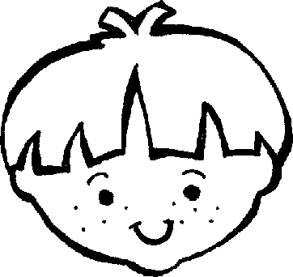
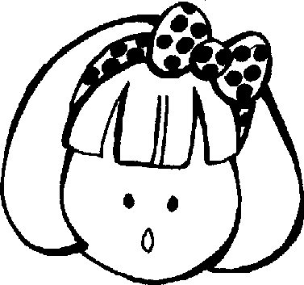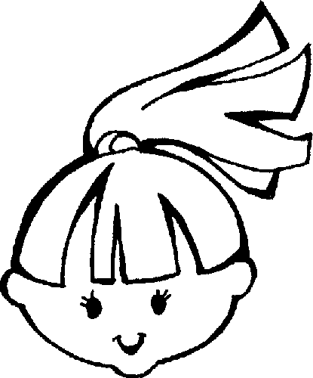

Nom : ____________________
Prénom : __________________

Mon nom et mon prénom
Mon nom de famille _________________________________________________________________________________________________________________________________

__________________________________________________________________________________________________________________________________________________________________________________________________________________________________________________________________

_________________________________________________________________________________________________________________________________

______________________________________________________________________________________________________________________________

__________________________________________________________________________________________________________________________________________________________________________________________________________________________________________________________________

_________________________________________________________________________________________________________________________________

_____________________________________________________________________________________________________________________________

__________________________________________________________________________________________________________________________________________________________________________________________________________________________________________________________________

_________________________________________________________________________________________________________________________________

________________________________________________________________________________________________________________________________

__________________________________________________________________________________________________________________________________________________________________________________________________________________________________________________________________

_________________________________________________________________________________________________________________________________

Mon prénom ________________________________________________________________________________________________________________________________

__________________________________________________________________________________________________________________________________________________________________________________________________________________________________________________________________

_________________________________________________________________________________________________________________________________

_________________________________________________________________________________________________________________________________

__________________________________________________________________________________________________________________________________________________________________________________________________________________________________________________________________

_________________________________________________________________________________________________________________________________

_________________________________________________________________________________________________________________________________

__________________________________________________________________________________________________________________________________________________________________________________________________________________________________________________________________

_________________________________________________________________________________________________________________________________

_________________________________________________________________________________________________________________________________

__________________________________________________________________________________________________________________________________________________________________________________________________________________________________________________________________

_________________________________________________________________________________________________________________________________

Mes camarades et moi
Mon nom de famille : ___________________________
Mon prénom : ___________________________

Mes camarades de classe :
Les filles | Les garçons
____________________  ____________________  ____________________  ____________________  ____________________  ____________________  ____________________  ____________________  ____________________ | ____________________  ____________________  ____________________  ____________________  ____________________  ____________________  ____________________  ____________________  ____________________
Je colorie les élèves de ma classe

Les filles en rose
Les garçons en bleu
Johnny
Norris
Cyril
Laura
Kelly
Ashley
Logan
Anaïs
Colin
Laurent
Logan
Lila
Vincent
Kimberley
Alex

____ filles + ____ garçons = ____ enfants
Je relie les mêmes prénoms

Kimberley Anaïs
Vincent Alex
Anaïs Kimberley
Kelly Lila
Lila Kelly
Alex Jhonny
Logan Vincent
Norris Norris
Jhonny Logan
Laurent Laurent
Je colorie mon nom et mon prénom

Anaïs Alex  Kimberley Norris Logan Lila Kelly Jhonny Vincent  Cyril Laurent | Leclercq Mochez Guérit Manouvrier  Busiau VarletMaus Dewulf Marlier  Restiaux Hoyez Declercq  Dieu Bellet
Je colorie le nom de mon institutrice
Mme Meunier
Mme Hosselet
Mme Vaccalluzzo

Je reconstitue les prénoms
Li
ris
cent
Kel
naïs
ny
A
Vin
John
ly
lex
gan
la
A
Nor
Lo

Je complète les prénoms
Kimberle… L…gan
…elly Li…a Al…x Vi...cent
Laur…nt Nor...is Ana…s

