



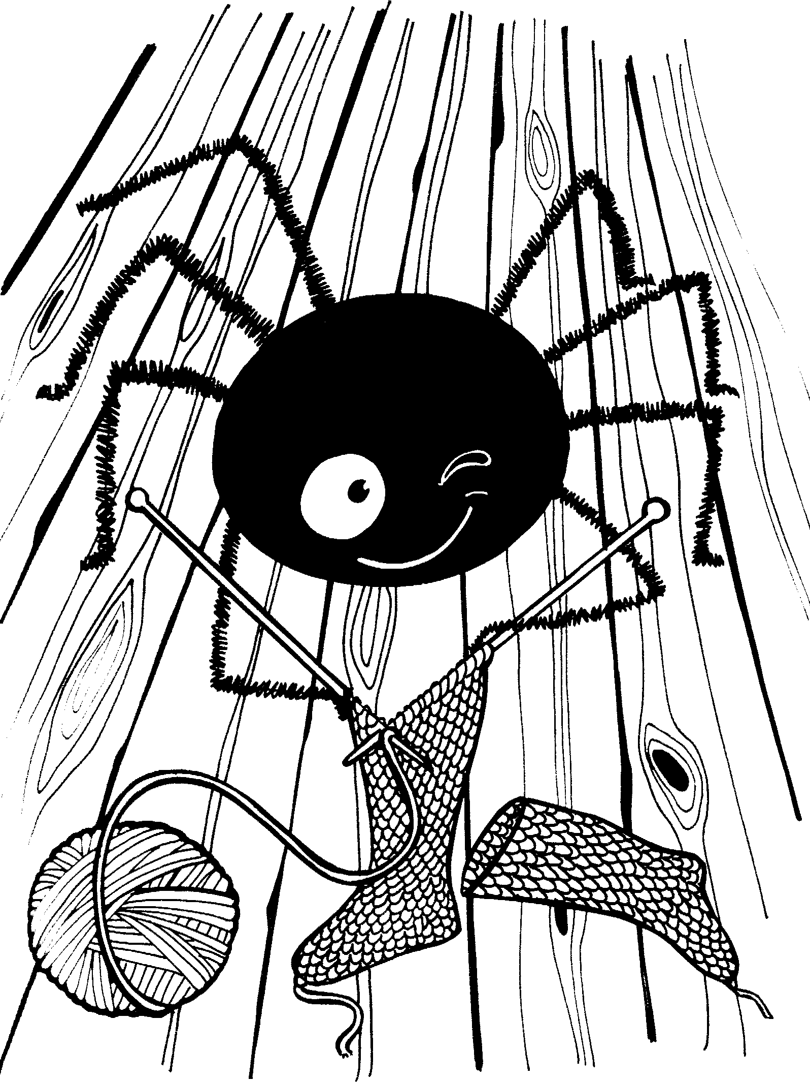


8 x 0 = 0
8 x 1 = 8
8 x 2 = 16
8 x 3 = 24
8 x 4 = 32
8 x 5 = 40
8 x 6 = 48
8 x 7 = 56
8 x 8 = 64
8 x 9 = 72
8 x 10 = 80



