Angles

With my set square, I can recognise right, obtuse or acute angles :

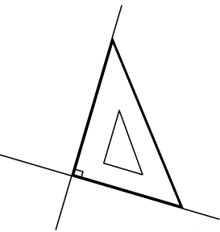
Right angle

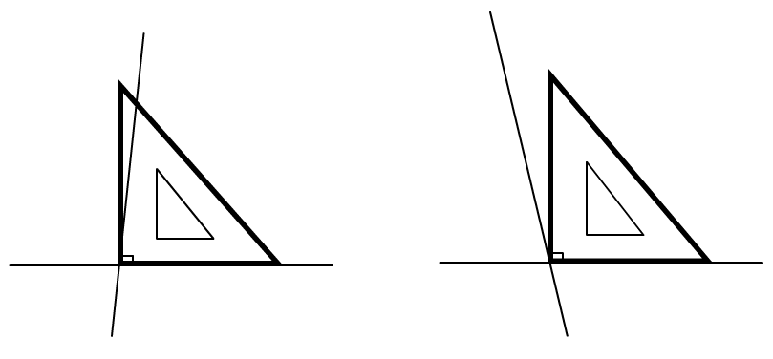
Obtuse angle
Acute angle

How to draw perpendicular lines :

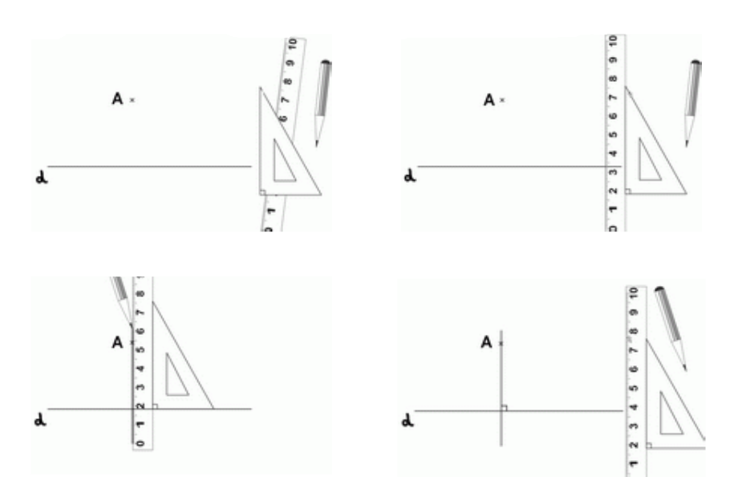

How to draw parallel lines :

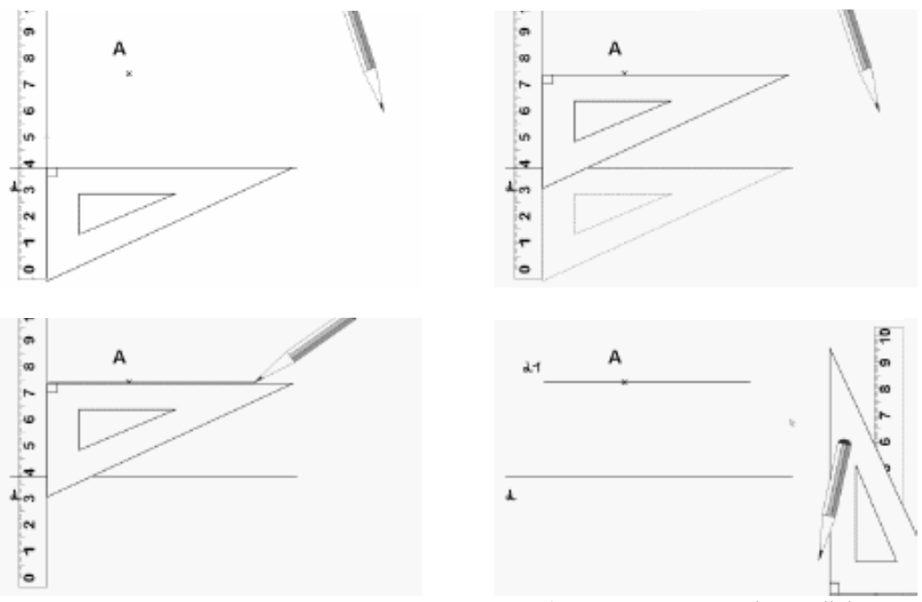

With my protractor, I can recognise angles :

An acute angle is between 0 and 90 degrees.
An obtuse anglais is between 90 and 180 degrees.
A right angle is 90 degrees.

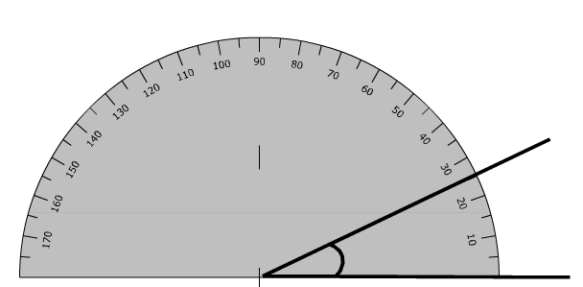

With my protractor, I can recognise angles :

An acute angle is between 0 and 90 degrees.
An obtuse anglais is between 90 and 180 degrees.
A right angle is 90 degrees.

