Acute Angle
An acute angle is an angle measuring
between 0 and 90 degrees.

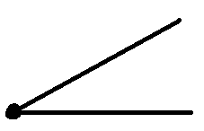
45°

Obtuse Angle
An obtuse angle is an angle measuring between 90 and 180 degrees.


135°

Right Angle
A right angle is an angle measuring
90 degrees.


90°

