SE DÉCRIRE
Can you describe yourself? - Yes I am ...
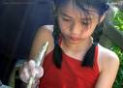 | 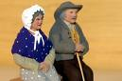 | 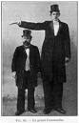 | 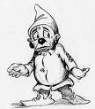 | 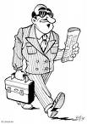
young  jeune | old  vieux | tall  grand | small  petit | of average height  De taille moyenne
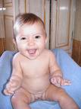 | 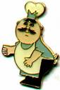 | 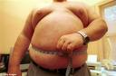 | 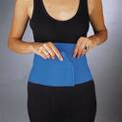 | 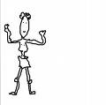
plump  dodu | fat  gros | obese  obèse | slim  maigre - mince | skinny  maigre
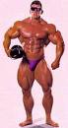 | 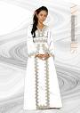 |  | 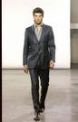
muscular  musclé | beautiful  belle | pretty - cute  jolie - mignonne | good-looking  beau- séduisant | handsome -attractive  beau - séduisant
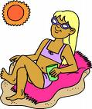 | 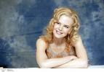 | 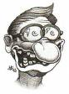 | 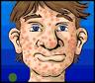 | 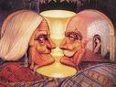
sun-tanned  bronzé | pale  pâle | ugly  laid | spotty  boutonneux | wrinkled  ridé

I have .... eyes.
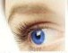 | 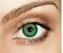 | 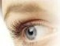 | 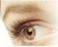 | 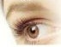 | 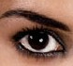
blue  bleus | green  verts | grey  gris | brown  marron | hazel  noisette | black  noirs

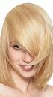 | 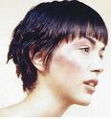 | 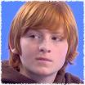 |  | 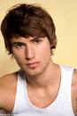 | 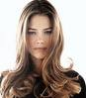 | 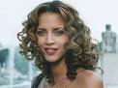 | 
I am  fair-haired  Je suis  blond(e) | I am  dark haired  J'ai les cheveux  noirs/foncés | I am  red haired  J'ai les cheveux  roux | I am  chestnut haired  J'ai les cheveux  châtains | I have  short hair  J'ai les cheveux  courts | I have  long hair  J'ai les cheveux  longs | I have a  medium length haircut  J'ai les cheveux  mi-longs | I have  a crewcut  J'ai les cheveux  en brosse

Dans l'exercice suivant, devinez de qui je parle.
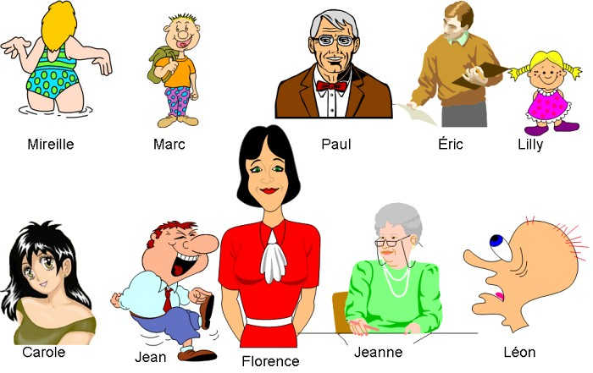
I am very young, small and a little bit plump. I am fair-haired.
People call me an ugly man, I have no hair and my eyes are blue.
I am a little boy but tall for my age. I am pretty cute and I have got a crewcut.
I am an old man. I have a wrinkled face and my hair is grey.
Perhaps a little bit fat, I am of average height. I have medium-length-haircut and I am blond-haired.
I am a teenager aged 15, I have got wide grey eyes and long black hair.
I am a good-looking man, chestnut-haired, and tall.
Not very tall, I am a funny man, rather fat. I come from the men's hairdresser's and I have short hair.
I am tall, slim and so beautiful! I have black hair, medium length, and green eyes.
I am becoming old now, I need a pair of glasses and my hair is grey.

