NAME : DATE :
FORM :

My daily routine /30

1) Listen and draw the hands on the clocks /7
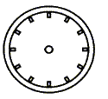

2) Complete with have / go / do /6
_____________ a shower ____________ to school ___________ breakfast
___________ to bed ____________ my homework ___________ a bath

3) Label those activities /10
Everyday ……
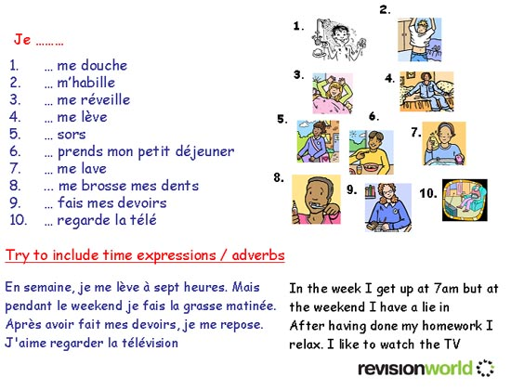
_____________________________________________
________________________________________
________________________________________
____________________________________
________________________________________

4) Write the activities in the correct order /7
1
2
3
4
5
6
7

A-She has math and English in the morning.
B-She brushes her teeth before going to school.
C-She goes to bed.
D-After school, she does her homework and then watches TV.
E-She reads a book in her bed.
F-She gets up and has breakfast.
G-Mandy wakes up at seven o’clock.
