
Nom : ______________________________

Multiplication par 5 ou 6

5 x 8 = _____
6 x 10 = _____
5 x 2 = _____
4 x 5 = _____
6 x 6 = _____
5 x 5 = _____

9 x 6 = _____
11 x 6 = _____
7 x 5 = _____
12 x 6 = _____
10 x 5 = _____
6 x 1 = _____
5 x 0 = _____
3 x 6 = _____
8 x 6 = _____
12 x 6 = _____
12 x 5 = _____
13 x 6 = _____
0 x 6 = _____
5 x 11 = _____
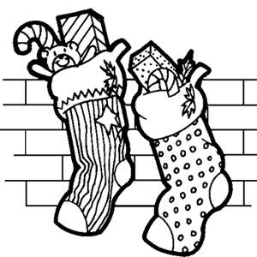
5 x 9 = _____

Multiplication par 7 ou 8

7 x 1 = _____
8 x 10 = _____
8 x 3 = _____
7 x 7 = _____
9 x 8 = _____
12 x 7 = _____
11 x 8 = _____
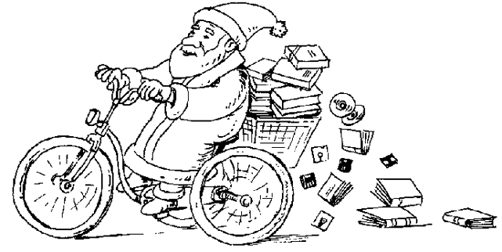
0 x 8 = _____
7 x 8 = _____
2 x 8 = _____

7 x 4 = _____
8 x 10 = _____
6 x 7 = _____
12 x 8 = _____
7 x 5 = _____
11 x 7 = _____
4 x 8 = _____
3 x 7 = _____

