What's the time?

Draw the time on the clock face!

It’s one O’clock. It’s half past two. It’s quarter past six. It’s quarter to six. It’s five past three. It’s ten to five.

What time is it?

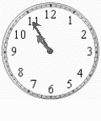  It's ......................... | 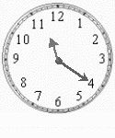 It's ......................... | 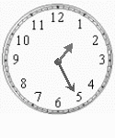 It's ......................... | 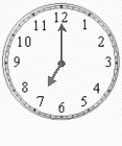 It's .........................

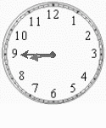 It's ......................... | 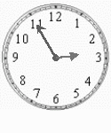 It's ......................... | 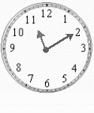 It's ......................... | 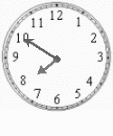  It's .........................

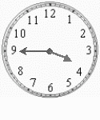 It's ......................... | 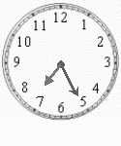 It's ......................... | 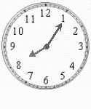 It's ......................... | 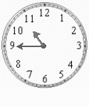 It's .........................

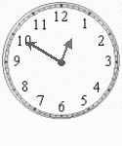 It's ......................... | 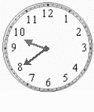 It's ......................... | 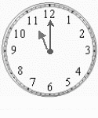 It's ......................... | It's .........................

Time dictation

- 7.15-7.45-6.45
- 8.30-9.30-6.30
Circle the correct clock
- 3.50-4.50-4.10
- 10.05-5.10-9.20
- 7.35-7.25-7.05
- 2.30-3.30-1.30
- 11.35-11.25-11.15
- 12.40-12.20-12.10
- 6.05-6.55-5.55

Write the good time!

- five to nine =
2. quarter past three =
3. twenty to six =
4. twelve o'clock =
5. half past five =
6. five past two =
7. quarter to seven =
8. ten past one =
9. ten to eight =
10. twenty-five past four =

1.
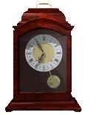It is ................................says the mantel clock. Tom is still sleeping in bed.
- GOOD MORNING TOM
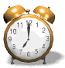It is .........................the alarm clock is ringing. 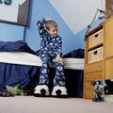Tom it's time to get up!

- 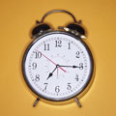It is ...................................Tom is having a shower.
- 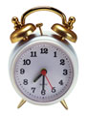It is…………………………... Breakfast is ready.
- 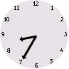It is ......................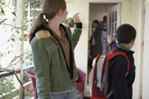Tom and his sister are going to school.

6.
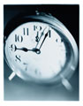It is ............................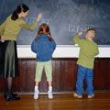Tom is at school, writing on the blackboard.

7.
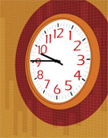It is .......................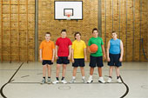The children are going to play basketball.
8.
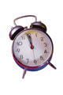It is ......................................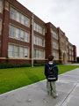Tom goes back home for lunch.
9.
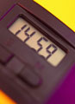It is ............................................Tom is working on a computer.

10.
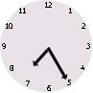It is ..............................Tom and his family are eating dinner.
GOOD NIGHT TOM

