Source pic http://www.ego4u.de/de/cram-up/vocabulary/time (02.04.07)

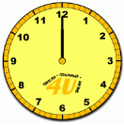 |  |  | - It's midnight (il est minuit).  - It’s midday (il est midi).  - It's 12 am (il est midi).  - It's 12 pm (il est minuit).  - It's twelve o'clock.  - Am = matin  - Pm = après-midi.
 | - It's two o'clock.  - It's two am / pm.  - It's two in the morning / in the afternoon. |  |  |  | - It's ten (minutes) past three.  - It's fifteen ten.
 | - It's quarter past ten.  - It's ten fifteen.  - It's ten fifteen in the morning / in the evening . |  |  |  | - It's twenty-five (minutes) past eight.  - It's eight twenty-five.
 | - It's eight thirty.  - It's half past eight. |  |  |  | - It's twenty to ten.  - It's nine forty.
 | - It's quarter to one.  - It's twelve forty-five.  Source pics: http://www.englisch-hilfen.de/en/exercises/time1.htm (02.04.07) |  |  |  | - It's ten to nine.  - It's eight fifty.
Time: 04.33  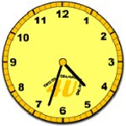 |  | - It's four thirty-three.  - It's four thirty-three in the morning  (in the afternoon).  - It’s twenty-seven to five. |  | Time: 09.08  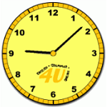 |  | - It's nine oh eight.  - It's nine oh eight a.m.  - It's eight past nine.
Time: 05.24  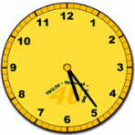 |  | - It’s five twenty-four.  - It’s five twenty-four in the morning.  - It’s twenty-four past five. |  | Time 13.57  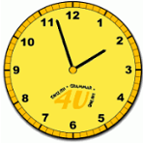 |  | - It's three (minutes) to two.  - It's thirteen fifty-seven.
Time: 07.52 |  | - It’s seven fifty-two.  - It’s seven fifty-two a.m.  - It’s eight (minutes) to eight. |  | Time: 19.21 |  | - It's nineteen twenty-one.  - It's twenty-one past seven.
Source pics: http://www.ego4u.de/de/cram-up/vocabulary/time (02.04.07)

The times of the day

Time | Morning | Afternoon | Evening | Night
Clock | 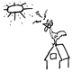 | 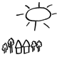 | 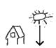 | 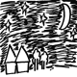
 | 00.01 - 12.00 | 12.01 to 17.00 | 17.01 to 22.00 | 22.01 – 24.00
Source pics: http://www.learn-english-online.org/Lesson16/Course/Lesson16.htm (02.04.07)

