M^{elle} A.Benoit

Une unité = 1 unité = 1 U =  = 1

Une dizaine = 1 dizaine = 1 D = = 10

Une centaine = 1 centaine = 1 C = 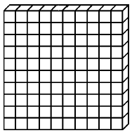 = 100

Un millier = 1 millier = 1 M = 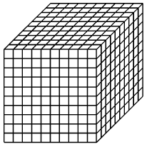 = 1000
1 U = 1 
M^{elle} A.Benoit

1 D = 1 = 10 U

1 C =  1 | 10 D = | 100 U
1 M =  1 | 10 C = | 100 D = | 1000 U

