Name : ___________________________ Date : ___________________________________

Measure : Capacity
L, dl, cl, ml

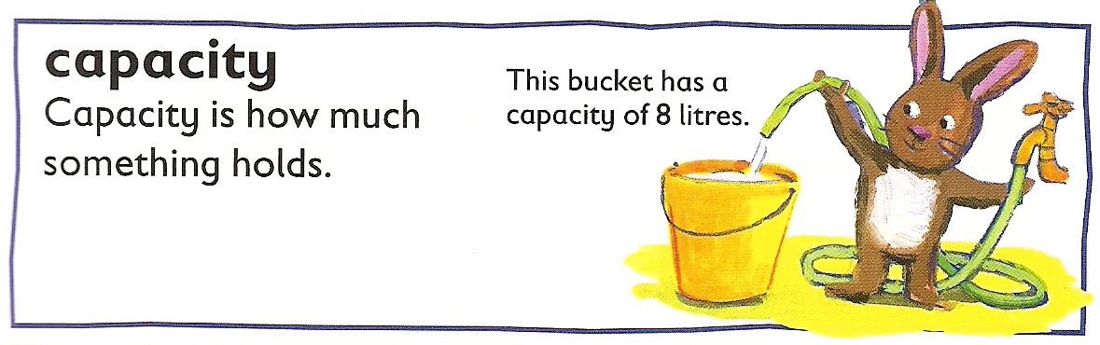

- Let’s remember the capacity abacus :

 | l | ___ | ___ | ml

- Convert and use the abacus if you need help :

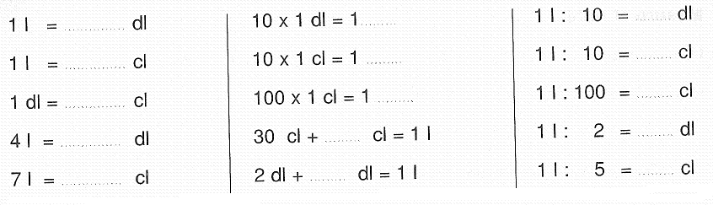
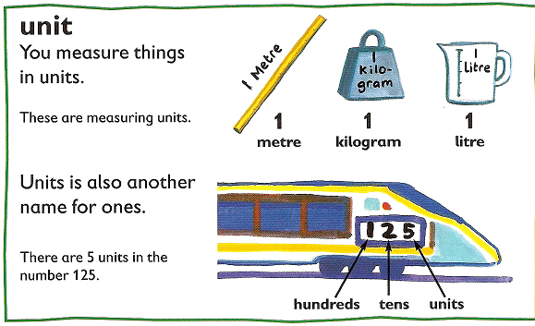

- Write the number in the correct unit :
( units are for capacity l, dl, cl and ml)

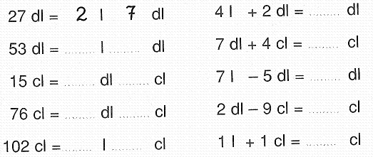

- Take a red coloring pencil and color the syrup. Be careful, the units are not the same ! ( 100 ml = 10 cl = 1 dl)

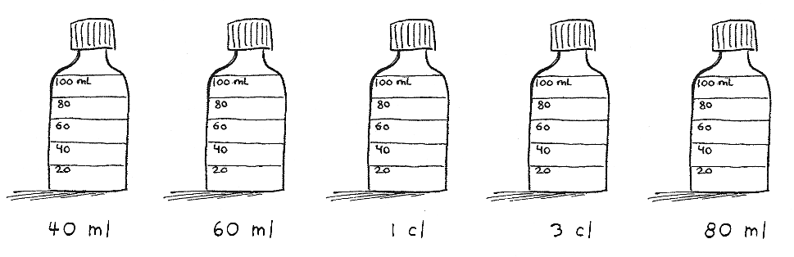

- Look at the drawings and write the correct unit :
(clues : dl, cl, l, l, ml, l, cl)

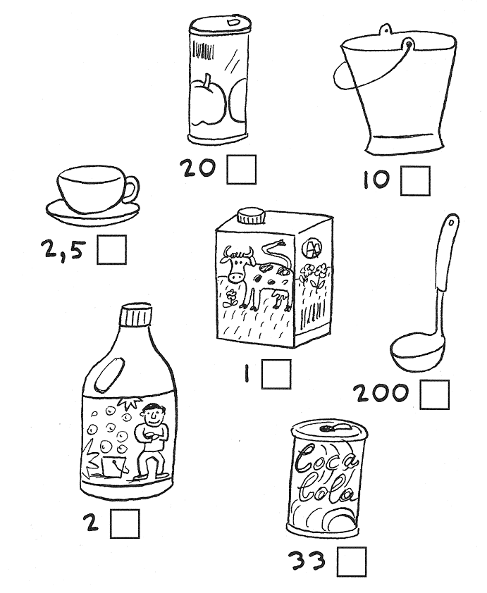

- Take a blue coloring pencil and color the correct amount of water :
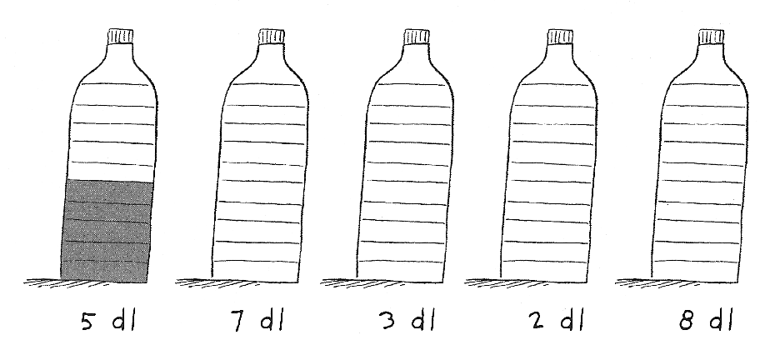

- Color the correct amount of paint :

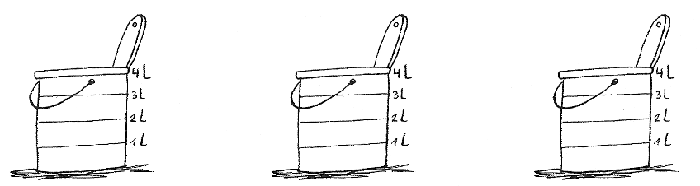

2 litres of green paint 4 litres of yellow paint 3 litres and a half of pink paint

- Color the correct amount of perfum in these bottles :

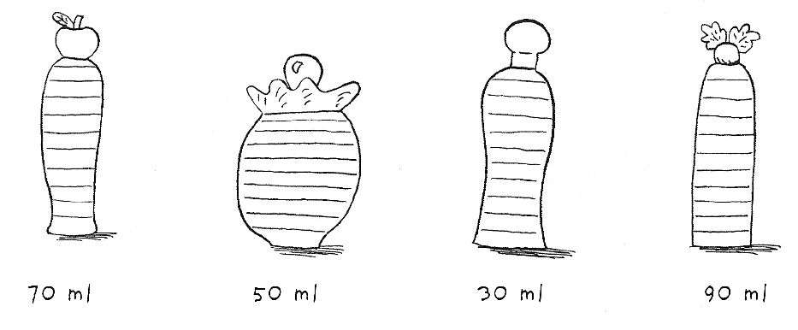
Don’t forget :
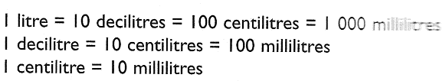

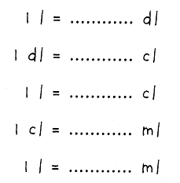

- Take a yellow coloring pencil and color the correct amount of lemonade :

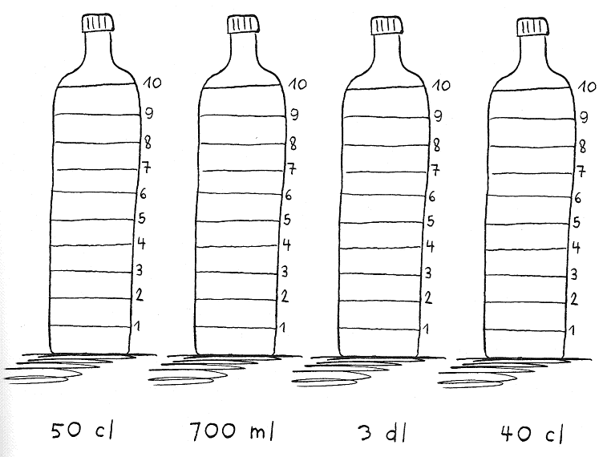
- Take an orange coloring pencil and color the correct amount of orange juice : ( clue : one measuring cup = 1 litre)

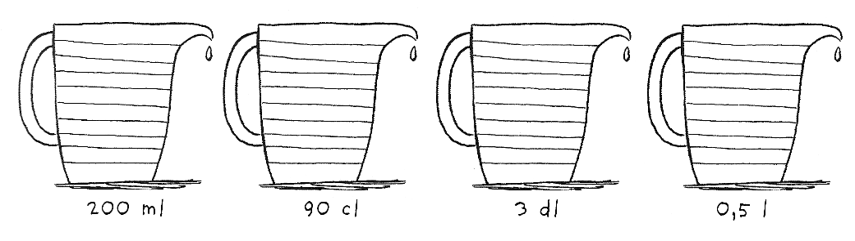

- Write the different amount from smaller to greater. Be careful, the units are not the same !!

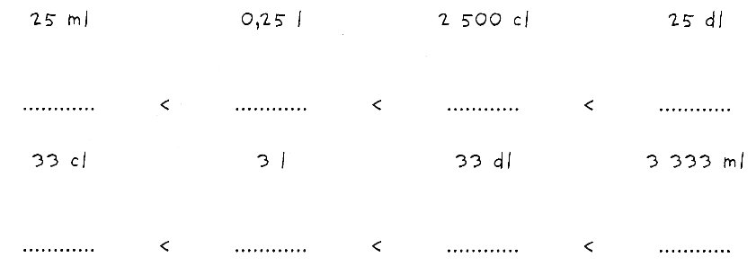

- Complete. Use the abacus if you want :

