Dictation help
Comment aider votre enfant pour la dictée ?

Je vous conseille d’écouter une première fois le cd sans interruption puis une deuxième fois en faisant répéter les phrases. Votre enfant peut ensuite lire les phrases à haute voix, s’entraîner à les écrire quelques fois et enfin écouter le cd comme si c’était le moment de la dictée. Je dis une première fois le mot, l’enfant le répète. Je dis ensuite la phrase, l’enfant la répète aussi. Et enfin, je dicte la phrase. Une fois la dictée terminée, il ne reste plus qu’à corriger les phrases. En général, je fais recopier une fois la phrase s’il n’y a qu’une petite erreur, trois fois s’il y a beaucoup d’erreurs.

Punctuation marks

Full stop | .
Comma | ,
Semi-colon | ;
Colon | :
Brackets | ( )
Inverted commas | “ ”
Question mark | ?
Exclamation mark | !

Week 1 : short a – s/t sounds

- Bad (p21) adj. – It’s bad for your health.
- Bag (p21) noun – I have a new bag.
- Fat (p40) adj. – Who’s fat? Me?
- Map (p57) noun – This is a map of the United States.
- Man (p56) noun – I’m a man.
- Wash (p91) verb – Wash your hands !
- Sad (p72) adj. – Don’t be sad !
- Take (p83) verb – Take your umbrella !

Week 2 : short e – r/n sounds

- Shell (p73) noun – I find sea shells in the sand.
- Wet (p91) adj. – I’m wet !
- Pet (p65) noun – I have one pet : it’s a dog.
- Hen (p20) noun – Hens make eggs.
- Tent (p84) noun – I live under a tent.
- Bed (p22) noun – Go to bed, Cindy !
- Forest (p42) noun – Do you like life in the forest?
- Neck (p24) noun – My neck hurts !
- Naked (p61) adj. – Are all animals naked?
- Rest (p70) verb – I need to rest a bit.
Week 3 : short i – c/l sounds

- Bring (p25) verb – The dog always brings the ball.
- English (p37) noun / adj. – Do you speak English ?
- Drink (p36) verb – What are you drinking ?
- Exit (p38) noun – Where’s the exit, please ?
- Hill (p47) noun – I live on this hill.
- Machine (p56) noun – This machine is out of order.
- Chicken (p20) noun – I like chicken !
- Bridge (p25) noun – The car is crossing the bridge.
- Big (p78) adj. – The elephant is big.
- Lip (p24) noun – I have two lips.

Week 4 : short o – m/p sounds

- Box (p23) noun – Surprise ! It’s a box of chocolates !
- Do (p35) verb – What are you doing ?
- Drop (p36) verb – I dropped my ice cream !
- Hobby (p47) noun – Do you have a hobby ?
- Rock (p71) noun – Mind the rocks !
- Dog (p20) noun – My dog doesn’t like frogs.
- Hot chocolate (p58) noun – I take a hot chocolate in the morning.
- Money (p59) noun – Give me some money.
- Polite (p66) adj. – Be polite with the policeman.
- Possible (p67) adj. – Is it possible to speak to Mr. Black ?
Week 5 : short u – b/f sounds

- Cut (p32) verb – Who wants to cut the bread ?
- Funny (p42) adj. – This is so funny !
- Jump (p52) verb – I can jump too.
- Luggage (p56) noun – Where is our luggage ?
- Umbrella (p89) noun – Do you like my new umbrella ?
- Truck (p88) noun – Trucks drive on the highway.
- Sun (p82) noun – I love the sun.
- Brush (p25) noun – Don’t forget your toothbrush.
- Run (p71) verb – Can you run ?
- Shut (p76) verb – Shut the door, please !

Week 6 : long a/ar – d/g sounds

- Birthday (p22) noun – Happy birthday, Caroline !
- Card (p26) noun – I often play cards with my friends.
- Call (p26) verb – Dinner is ready. Call dad and mum !
- Complain (p30) verb – Stop complaining, it’s Christmas !
- Fair (p38) adj. – It’s fair !
- Hate (p46) verb – I hate cheese.
- Lake (p53) noun – A lake is smaller than a sea.
- Lawn (p54) noun – I’m proud of my lawn.
- Mail (p56) noun – You’ve got mail.
- Name (p61) noun – What’s your name ?
Week 7 : long e/er – h/v sounds

- Agree (p18) verb – I agree with you.
- Beat (p22) verb – You can’t beat me.
- Idea (p50) noun – I have an idea !
- Cheap (p27) adj. – The food is cheap here.
- Clean (p29) adj. – Mummy, my hands are clean.
- New (p61) adj. – We need a new machine.
- Sheet (p75) noun – I’m writing on a sheet of paper.
- Sheep (p20) noun – Shirley is a nice sheep.
- Season (p72) noun – The 4 seasons are spring, summer, fall and winter.
- Deep (p34) adj. – She’s in a deep sleep.

Week 8 : long i/ir – k/j sounds

- Blind (p23) adj. – Fido’s master is blind.
- Child (p27) noun – The child is playing in the playground.
- Decide (p34) verb – You decide !
- Describe (p34) verb – Describe the painting.
- Exercise (p38) noun – This exercise is very easy.
- Fine (p41) adj. – What a fine view !
- Fight (p40) verb – Stop fighting !
- Fire (p41) noun – It’s a lovely fire.
- Kind (p52) adj. – That’s kind of you.
- Night (p62) noun – We go out at night.
Week 9 : long o/or – z/w sounds

- Afternoon (p18) noun – Are you at home this afternoon ?
- Blow (p23) verb – The wind is blowing.
- Choose (p27) verb – I choose this one !
- Cold (p29) adj. – I’m cold.
- Close (p29) verb – Close the door, please.
- Cook (p30) verb – I love cooking.
- Hold (p47) verb – Hold this for a moment.
- Hope (p47) verb – Good news, I hope.
- Know (p53) verb – I don’t know.
- Morning (p60) noun – What a beautiful morning !

Week 10 : long u/ur – y/q/x sounds

- Curly (p32) adj. – She has curly hair.
- Curtain (p32) noun – Can you pull the curtains ?
- Disturb (p35) verb – Do not disturb.
- Excuse (p38) verb – Excuse me !
- Be in a hurry (p48) verb – I’m in a hurry.
- Juice (p52) noun – I’d like an orange juice, please.
- Rule (p71) noun – Do you know the rule of the game ?
- Year (p93) noun – A year has twelve months.
- Queen (p69) noun – The queen and the king are in their palace.
- Example (p37) noun – Follow my example.
Week 11 : ee – ch/th/thr sounds

- Green (p29) adj. – The grass is green.
- Feel (p40) verb – How are you feeling ?
- Bath (p21) noun – She is in the bath.
- Christmas (p27) proper noun – Merry Christmas !
- Change (p27) verb – I changed the bulb.
- Clothes (p29) noun – I need some new clothes.
- Match (p57) noun – They lost the match.
- Throw (p85) verb – He’s throwing the ball to his dog.
- Thing (p85) noun – What’s this thing ?
- Think (p85) verb – I think you’re too young.

Week 12 : Ea (i) – sh/wh sounds

- Dream (p35) noun – I had a strange dream last night.
- Eat (p37) verb – I’m eating a piece of bread.
- Easy (p36) adj. – It’s very easy.
- Leaf (p54) noun – Look at those leaves ! It’s autumn.
- Leave (p54) verb – I don’t want to leave.
- Cushion (p32) noun – This is my cushion.
- Fish (p41) noun – I love fish !
- White (p29) adj. – Where is my black and white cat ?
- Punish (p68) verb – I am punished.
- Shelf (p75) noun – Put it on the shelf.
Week 13 : Ai – sp/sl sounds

- Be afraid (p18) verb – I’m never afraid.
- Downstairs (p35) adj. /adv.– He is already downstairs.
- Mountain (p60) noun – It is the highest mountain in the world.
- Nail (p61) noun – My nails are red.
- Speed (p79) noun – Reduce your speed !
- Spend (p79) verb – I spend too much money.
- Spring (p79) verb – Come on, spring !
- Sleep (p77) verb – The dog is sleeping.
- Slice (p77) noun – One slice of cake for me.
- Slow (p77) adj. – You’re slow !

Week 14 : Oo – sc/sm sounds

- Kangaroo (p20) noun – The kangaroo likes to jump.
- Blood (p23) noun – There’s blood on my knee !
- Book (p23) noun – This is my favourite book.
- Floor (p41) noun – Put it on the floor.
- Scare (p72) verb – He scared me !
- Scarf (p31) noun – I wear a scarf around my neck.
- Smell (p77) verb – It smells bad.
- Smile (p77) verb – Smile, please !
- Small (p78) adj. – The mouse is very small.
- School (p72) noun – I go to school every morning.
Week 15 : revision dictation

- Clap (verb) – If you’re happy and you know it clap your hands !
- Pen (noun) – Could you lend me your pen ?
- Sink (noun) – Go wash your paintbrush in the sink.
- Locker (noun) – Put your binder in your locker.
- Haircut (noun) – I have a new haircut.
- Snail (noun) – You are as slow as a snail !
- Cheat (verb) – If you cheat you don’t learn !
- Mind (verb) – Mind your own business !
- Bow (noun) – I put a nice bow on the Christmas tree.
- Mule (noun) – Saint Nicholas travels with a mule.

Week 16 : Ea (è) – st/sk/ck sounds

- Break (p25) verb – Oh, the glass is broken !
- Great (p45) adj. – I love your coat. It’s great.
- Health (p46) noun – You are in good health.
- Heavy (p46) adj. – My bag is too heavy.
- Star (p81) noun – Look at the stars !
- Story (p82) noun – This is a nice story.
- Stroke (p82) verb – I like stroking my cat.
- Alarm clock (p18) noun – The alarm clock goes off at seven o’clock.
- Ask (p21) verb – Can I ask you something ?
- Package (p64) noun – I have a package for you.
Week 17 : Ou – sn/sq/qu sounds

- Cloud (p29) noun – There are big white clouds.
- Cough (p32) verb – It makes me cough.
- Dangerous (p34) adj. – This road is very dangerous.
- Delicious (p34) adj. – This is delicious !
- Snow (p79) verb – It’s snowing.
- Sneakers (p31) noun – I wear sneakers to play basketball.
- Square (p75) noun – The square has four equal sides.
- Question (p69) noun – That’s a difficult question.
- Queue (p69) noun – There’s a long queue.
- Quiet (p69) adj. – I live in a quiet town.

Week 18 : Au – sw/tw sounds

- Swallow (p83) verb – You must swallow that syrup.
- Sweet (p83) adj. – My tea is too sweet.
- Sweets (p83) noun – Do you like sweets ?
- Swim (p83) verb – I love swimming.
- Aunt (p39) noun – My aunt is the sister of my mum.
- Daughter (p39) noun – I am the daughter of my father.
- Sausage (p43) noun – I like sausages with ketchup.
- Laugh (p54) verb – Why are you laughing ?
- Restaurant (p70) noun – Where can I find a good restaurant ?
- Switch off/on (p83) verb – Switch the light on.
Week 19 : Oa – br/tr sounds

- Raincoat (p31) noun – It’s raining ! Quick, my raincoat !
- Cupboard (p49) noun – Put the cup in the cupboard.
- Toast (p58) noun – I like toasts with butter and jam.
- Road (p71) noun – There’s no traffic on this road.
- Boat (p88) noun – I’m going to England by boat.
- Brave (p25) adj. – Be brave !
- Breakfast (p58) noun – What did you have for breakfast ?
- Tree (p86) noun – I like this tree.
- Try (p86) verb – Try this computer.
- Trousers (p31) noun – My trousers are red and yellow.

Week 20 : Ui – gr/fl/gl sounds

- Build (p25) verb – I am building my house.
- Biscuit (p58) noun – I like biscuits, especially cookies !
- Guitar (p60) noun – My dad can play the guitar.
- Fly (p20) noun – There’s a fly in my soup !
- Fly (p42) verb – I can fly !
- Flower (p41) noun – I like to give flowers to my mum.
- Glad (p45) adj. – I’m glad to see you.
- Glasses (p45) noun – She wears glasses.
- Ugly (p89) adj. – You are ugly.
- Grass (p45) noun – Keep off the grass.
Week 21 : Ie – dr/cr sounds

- Lie (p55) noun – That’s a lie !
- Lie (p55) verb – Lie [lai] Lie on your back.
Lie [lie] Don’t lie !
- Tie noun – My tie is red.
- Pie (p58) noun – I like apple pies !
- Draw (p35) verb – I love drawing.
- Dress up (p44) verb – I dressed up as a princess.
- Dry (p36) adj. – My shirt is dry.
- Cross (p32) verb – I can cross now.
- Cry (p32) verb – Don’t cry !
- Crazy (p32) adj. – You’re crazy !

Week 22 : Pr/wr – ap/an/at sounds

- Apricot (p43) noun – Apricots are good in summer.
- Prefer (p67) verb – I prefer tea to coffee.
- Present (p67) noun – I have a present for you.
- Proud (p68) adj. – I’m proud of you.
- Apartment (p19) noun – I live in this apartment.
- Angry (p19) adj. – Don’t be angry.
- Answer (p19) verb – Can you answer my question ?
- Apple (p43) noun – Apples grow in autumn.
- Attic (p49) noun – I like to play in the attic.
- Hat (p31) noun – Where is my hat ?
Week 23 : Cl/bl – En/are/all sounds

- Classroom (p28) noun – We have a very nice classroom.
- Clever (p29) adj. – Monkeys are clever !
- Climb (p29) verb – I can climb trees.
- Blackboard (p28) noun – Miss Gabrielle writes on the blackboard.
- Blanket (p22) noun – Do you need a blanket ?
- Engine (p88) noun – The engine of the car won’t start !
- Enter (p37) verb – Do not enter.
- Fall (p38) verb – You’re going to fall !
- Be careful (p26) verb – Be careful !
- Prepare (p67) verb – I’m preparing dinner.

Week 24 : Fl/pl – ub/ate/ail sounds

- Flute (p60) noun – I like to play the flute.
- Butterfly (p20) noun – Spring is the season to see butterflies.
- Pleasure (p66) noun – Can you help me ? With pleasure.
- Pleasant (p66) adj. – We wish you a pleasant flight.
- Gate (p49) noun – Stop at the gate !
- Sailing boat (p73) noun – I spent my holiday on a sailing boat.
- Play (p66) verb – Can I play with you ?
- Place (p66) noun – Do you know a place called “Green Café” ?
- Plane (p88) noun – I am scared in planes.
- Unpleasant (p89) adj. – There’s an unpleasant smell.
Week 25 : Str/scr – Ay/ain/aw sounds

- Strange (p82) adj. – That’s strange.
- Strong (p82) adj. – How strong you are !
- Strawberry (p43) noun – I’m allergic to strawberries.
- Screen (p28) noun – There is an enormous screen in the cinema.
- Stay (p81) verb – Stay with me !
- May (p59) proper noun – We celebrate Mother’s Day in May.
- Train (p88) noun – I’m going to the sea by train.
- Rain (p69) verb – It’s raining !
- Way (p91) noun – I do it this way.
- Street (p87) noun – I live in this street.

Week 26 : Ng/ngth – Ake/ave sounds

- Make (p56) verb – Let’s make peace.
- Take off (p83) verb – Don’t take your clothes off.
- Wake up (p90) verb – I wake up at seven every morning.
- Have (p46) verb – Do you have brothers and sisters ?
- Wave (p73) noun – It’s fun to jump in the waves.
- Belong (p22) verb – This bike belongs to my father.
- Shave (p75) verb – I never shave.
- Shake (p74) verb – Don’t shake the bottle !
- Song (p79) noun – It’s a beautiful song.
- Long (p55) adj. – The giraffe has a long neck.
Week 27 : Eat/ear/eep sounds

- Keep (p52) verb – Can you keep a secret ?
- The Earth (p36) proper noun – The Earth is round.
- Early (p36) adj. – I get up early every morning.
- Hear (p46) verb – I can’t hear you !
- By heart (p46) adj. – Learn it by heart.
- Learn (p54) verb – I’m learning English.
- Near (p61) adj. – I live near here.
- Tear (p84) noun – He’s in tears.
- Wear (p91) verb – I never wear trousers.
- Ear (p24) noun – I’m all ears !

Week 28 : Ide/ice/ine/ike sounds

- Examine (p37) verb – The doctor wants to examine you.
- Dice (p44) noun – I like to play with dice.
- Medicine (p57) noun – Here’s your medicine.
- Office (p63) noun – I work in a large office.
- Ride (p71) verb – I can ride !
- Seaside (p72) noun – We’re going to the seaside.
- Motorbike (p88) noun – Don’t drive too fast on your motorbike !
- Like (p55) verb – I like sweets but I prefer chocolate.
- Nice (p62) adj. – He’s a nice guy.
- Price (p67) noun – It’s a high price.
Week 29 : Owe/oke/old sounds

- Allow (p19) verb – This is not allowed !
- Follow (p42) verb – Follow me !
- Gold (p45) adj. – It’s a gold ring !
- Old (p63) adj. – This woman is very old.
- Shadow (p74) noun – Where’s my shadow ?
- Smoke (p77) noun – Look at the smoke !
- Show (p76) verb – Show me your favourite toy.
- Town (p86) noun – It’s a small town.
- Cow (p20) noun – Cows make milk.
- Brown (p29) adj. – The trunk of the tree is brown.

Week 30 : Ook/oop/ore sounds

- Look (p55) verb – Look at me !
- Look for something (p56) verb – What are you looking for ?
- Exercise book (p28) noun – “Language art” is one of our exercise books.
- Cook (p51) noun – Caroline’s daddy is a cook.
- More adj. – I need more paint.
- Score (p72) noun – The score is one all.
- Store (p87) noun – I bought my ball in a toy store.
- Hook noun – Captain Hook is not nice to Peter Pan.
- Snore (verb) – I sometimes snore in my sleep.
- Sore adj. – I have a sore throat.
Week 31 : Ack/ash/ant sounds

- Black (p29) adj. – Black is not a color.
- Jacket (p31) noun – Have you seen my jacket ?
- Packet (p64) noun – I’d like a packet of crisps, please.
- Bank (p87) noun – I put all my money in the bank.
- Ankle (p24) noun – I hurt my ankle during a football game.
- Back (p24) noun – He put a paper fish on my back !
- Banker (p51) noun – The banker gives me advice about money.
- Fashion (p40) noun – It’s the new fashion.
- Mashed potatoes noun – I like mashed potatoes with peas.
- Blank noun – Fill in the blanks.

Week 32 : Ent/ell/est/edge sounds

- Accident (p18) noun – It’s not a serious accident.
- Arrest (p19) verb – The Police arrested the gangsters quickly.
- Different (p35) adj. – We are different.
- Excellent (p38) adj. – This is excellent !
- Honest (p47) adj. – This man is not very honest.
- Innocent (p50) adj. – I am innocent.
- Sell (p74) verb – You should sell it.
- Bell noun – The bell rings at 8.25 am.
- Chest (p24) noun – My heart beats in my chest.
- Dentist (p51) noun – I have a special doctor for my teeth: the dentist !
Week 33 : Ip/in/it sounds

- Dolphin (p20) noun – The dolphin is a very intelligent animal.
- Begin (p22) verb – Who begins ?
- Chin (p24) noun – The chin is part of the face.
- Insist (p50) verb – Please, go first. I insist.
- Intelligent (p50) adj. – They are so intelligent !
- Violin (p60) noun – The violin is a beautiful instrument.
- Prince (p67) noun – He’s Prince Charming.
- Sit (p77) verb – Sit here !
- Visit (p90) verb – I visited London last year.
- Win (p92) verb – I always win !

Week 34 : Ick/ill/ing sounds

- Boring (p23) adj. – The film is boring.
- Disgusting (p35) adj. – It’s disgusting.
- Fill (p40) verb – Fill it with water.
- Evening (p37) noun – Have a nice evening !
- Exciting (p38) adj. – This is so exciting !
- Ill (p50) adj. – Are you ill ?
- King (p53) noun – Who is the king of the kingdom ?
- Kill (p52) verb – I’ll kill you if you tell her !
- Pillow (p65) noun – I like my big pillow !
- Wedding (p91) noun – This is a picture of our wedding.
Week 35 : ot/op/ock sounds

- Bottle (p23) noun – I have a full bottle.
- Carrot (p43) noun – Eat carrots! It’s good for your sight.
- Hot adj. – I like summer because the weather is hot.
- Open (p63) verb – I’m opening the window.
- Parrot (p20) noun – Coco the parrot repeats everything I say.
- Poppy (p41) noun – I have poppies in my garden.
- Shop assistant (p51) noun – I need help from the shop assistant.
- Sock (p31) noun – I forgot my socks at the swimming pool !
- Stop (p81) noun – This is the bus stop.
- Clock noun – What time is it ? Look at the clock !

Week 36 : Uck/ump/ush/um/ug sounds

- Plum (p43) noun – We eat plums in autumn.
- Plumber (p51) noun – The plumber fixed the tap.
- Trumpet (p60) noun – My cousin Ben plays the trumpet.
- Push (p68) verb – Liz is pushing a pushchair.
- Cucumber (p43) noun – I can prepare a delicious cucumber salad.
- Drum (p60) noun – Don’t play with your drum ! I’m trying to sleep:!
- Duck (p20) noun – The duck goes “Quack quack !”.
- Tummy (p24) noun – I have a tummy ache !
- Mum (p39) noun – My mum makes the best plum tart in the world.
- Mushroom (p43) noun – We went to the forest to pick mushrooms.

Name : ________________________ Date : ____________________________________
Voc - dict

Dictation contract 1
short a – s/t sounds

- Look for the dictation words in your Bescherelle :
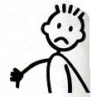
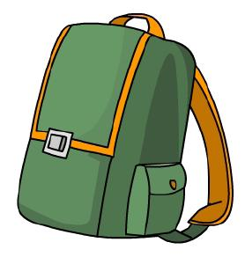
- _________ (p21) – It’s ___________ for your health.
- ________ (p21) – I have a new _________.
- ________ (p40) – Who’s ________? Me?
- ________ (p57) – This is a ________ of the United States.
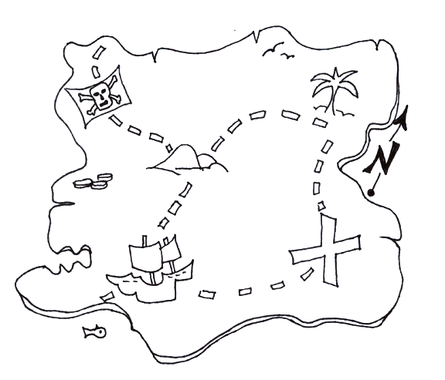
- ________ (p56) – I’m a _________.
- _________ (p91) – ___________ your hands !
- _________ (p72) – Don’t be _________ !
- _________ (p83) verb – _________ your umbrella !
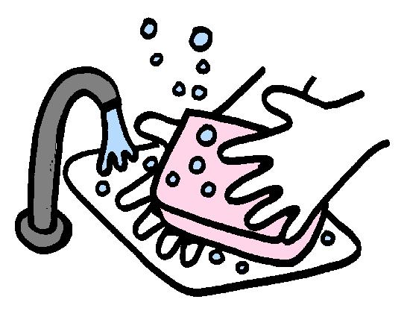
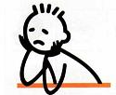

- Find the correct definition :
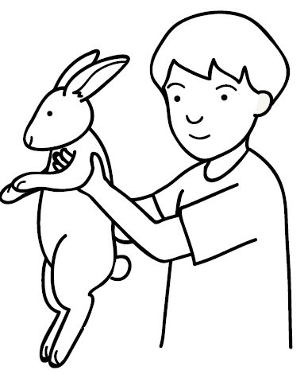
- ______ (p40) adj. – The opposite of thin. Too big.
- _______ (p21) adj. – Not good. The opposite of good.
- _______ (p21) noun – Something I put my books in.
- _______ (p57) noun – Piece of paper with countries.
- ________ (p56) noun – The opposite of woman.
- ________ (p72) adj. – The opposite of happy.
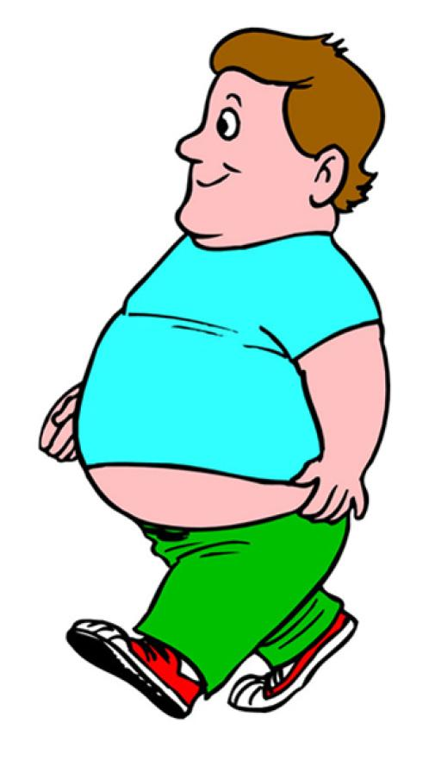
- ________ (p91) verb – The action to clean something.
- _________ (p83) verb – The opposite of giving.

- Invent a sentence with your neighbor. Use the words !

bad - bag - fat – map – man – wash – sad – take

_________________________________________________
_________________________________________________
_________________________________________________
_________________________________________________
_________________________________________________
_________________________________________________
_________________________________________________
_________________________________________________

- Write the nouns in the plural and copy the sentences :

Bag – I have a new bag.
 bags – I have two new bags. ____________________________________

Map – This is a map of the United States.
 maps – These are two maps of the United States.
_________________________________________________

Man – I’m a man.
 men – They are men. ____________________________________

- Find the mistakes and write the words correctly:

Baad  __________________________
Bage  __________________________
Fath  __________________________
Mapes  __________________________
Manne  . __________________________
Wach  __________________________
Scad  __________________________
Taike  __________________________

- Link to the correct definition. Use a ruler and colors :

The opposite of thin. Too big. *
Not good. The opposite of good. *
Something I put my books in. *
Piece of paper with countries. *
The opposite of woman. *
The opposite of happy. *
The action to clean something. *
The opposite of giving. *
- wash
- take
- sad
- map
- man
- fat
- bag
- bad

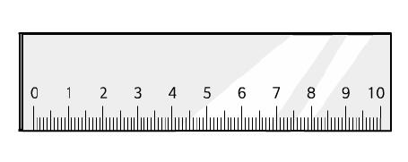

- Put the letters in the correct order :

awhs  __________________________
aekt  __________________________
asd  __________________________
apm  __________________________
amn  __________________________
tfa  __________________________
gad  __________________________
dab  _________________________

Search the words. Use colors if you want :

bad - bag - fat – map – man – wash – sad – take

(word search fait avec vocabulary challenge)

- Crossword: (  down  up  across )

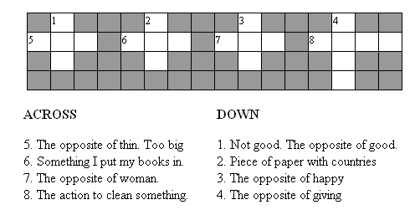

- Put the words in the correct order. Write the sentences.
Don’t forget the capital letter and the punctuation !

your it’s health. for bad
_____________________________________________

new I have bag.a
_____________________________________________

who’s me? fat?
_____________________________________________

United States.this the of map is a
_____________________________________________

man. I’m a
_____________________________________________

your wash hands !
_____________________________________________

sad ! don’t be
_____________________________________________

your umbrella ! take
_____________________________________________

- Short a sounds :

