Itchy facts : LICE

Head lice (sing. louse) are parasitic insects that hide in the hair of people and suck their blood.

Classification
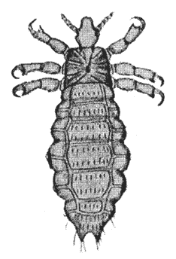

Branch : Invertebrates
Class : Insects
Group : Pediculidae
Species : Head louse (Pediculus Humanus)

LIFE CYCLE
Lice reproduce all year through.
Their life cycle (from egg to adult) is about 21-27 days long.
Female usually hatch eggs at night.
They lay about 4 to 8 eggs per night.

Adult lice: A louse can live up to 30 days on human scalp (head’s skin). Lice must feed on blood to survive. If they fall off the head, they will die within 2 days.
→ Its head has one pair of antenna and tiny eyes.
→ The thorax holds 3 pairs of short feet.
→ Each foot has a little claw (to grasp the hair).
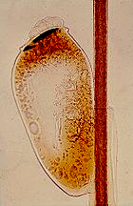
Eggs (nits): About as large as a grain of pepper, they look like tiny yellow or brown dots. Lice lay nits on hairs close to the skin's surface, where the temperature is perfect for keeping warm until they hatch. Nits look sort of like dandruff, only they can't be removed by brushing. Lice eggs hatch within 1 week after they're laid.

Nymphs: Nits hatch as nymphs, which look like adult lice but smaller. They feed on blood and become adults in about 1 or 2 weeks.

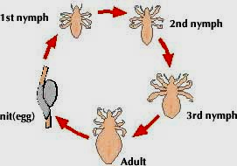
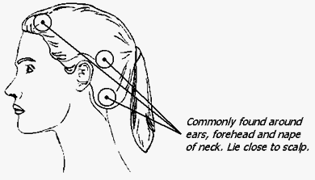
Habitat
These particular lice live on human scalp (head’s skin).
They usually keep warm behind ears or in the nape of the neck. This parasite survives on every continent, wherever man lives.

Diet (Food)
Young and adult head lice feed on blood several times a day.
They pierce the skin (using adapted mouthparts) and suck blood. Their body fattens like a balloon while feeding.

Behaviour
Lice move around rapidly on scalp and hair but it cannot jump or fly.
Lice aren't dangerous but they are contagious and can just be really annoying.
Their movements tickle the scalp.
Their bites may cause the head to become itchy and cause small, red bumps or sores from scratching.
.

VISUAL DIAGNOSIS
■ Look closely through the hair and scalp.
■ Adult lice are about the size of a little seed, and appear greyish-white. Nymphs are smaller.
■ Look for nits attached near the base of scalp hairs.

TREATMENT AND PREVENTION
■ Remove all clothing.
■ Shampoo hair with special lice shampoo ; long hair may need a second treatment.
■ Dress with clean clothing.
■ If the lice still appear after 8–12 hours, see your doctor.
■ After treatment, comb hair with a nit comb, which often comes with the lice shampoo,
every 2 to 3 days. Vinegar may also help.
■ Wash all clothing and bed clothing used by the infested person during the 2 days before treatment.
■ Soak combs and hair brushes in rubbing alcohol for at least one hour, then wash them in clean soapy water.
■ Vacuum carpets and rugs.
■ Do not worry about pets. Lice are only attracted to humans.

