Alphabetical order

Stick the words in the alphabetical order

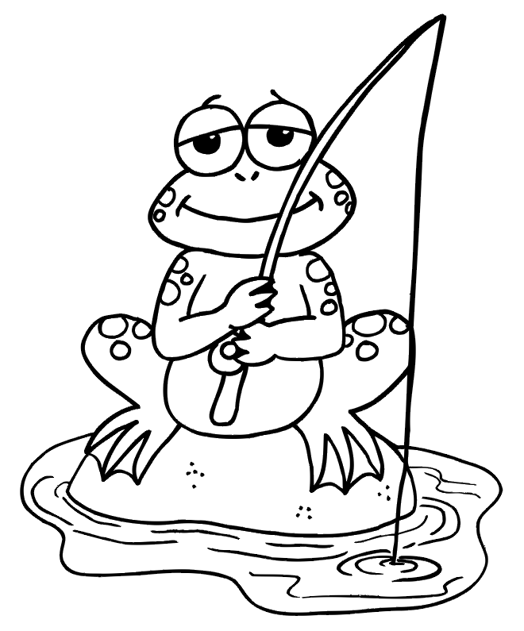

family | mouse | read
father | banana | smile
school | minute | folder
song | mountain | book
cat | purple | winter
ape | present | dad

family | mouse | read
father | banana | smile
school | minute | folder
song | mountain | book
cat | purple | winter
ape | present | dad

