Carnival party
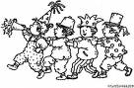

Orange, purple, yellow and blue
All that colors just for you!

Jump, sing and dance,
There is no fence.

A whole day just to play…
That’s of course carnival day!

