Ik ben bang!!

VAM | ● ● | OOK | ● ●
TOVE | ● ● | TER | ● ● | 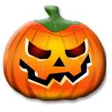
SP | ● ● | PIER | ● ●
HE | ● ● | POEN | ● ●
MONS | ● ● | NAAR | ● ●
SPOOK | ● ● | KS | ● ●
POM | ● ● | AAT | ● ● | 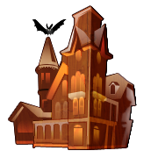
PIR | ● ● | HUIS | ● ●

