Name : _______________________ Date : __________________________________
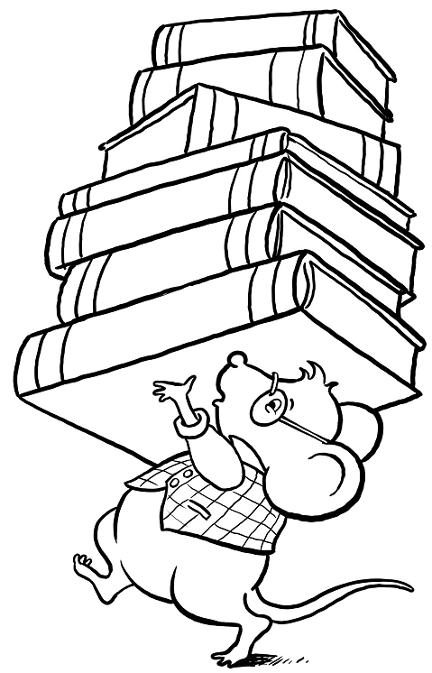
History

History : November 11th
Veteran Day - Armitice

Reading comprehension :

In 1921, an unknown World War I American soldier was buried in Arlington National Cemetery. This site, on a hillside overlooking the Potomac River and the city of Washington, became the focal point of reverence for America's veterans.
Similar ceremonies occurred earlier in England and France, where an unknown soldier was buried in each nation's highest place of honor (in England, Westminster Abbey; in France, the Arc de Triomphe). These memorial gestures all took place on November 11, giving universal recognition to the celebrated ending of World War I fighting at 11 a.m., November 11, 1918 (the 11th hour of the 11th day of the 11th month). The day became known as "Armistice Day".
Armistice Day officially received its name in America in 1926 through a Congressional resolution. It became a national holidiay 12 years later by similar Congressional action. If the idealistic hope had been realized that World War I was "the War to end all Wars," November 11 might still be called Armistice Day. But only a few years after the holiday was proclaimed, war broke out in Europe. Sixteen and one-half million Americans took part. Four hundred seven thousand of them died in service, more than 292,000 in battle.

- How old is the tradition of Veterans? _________________________

- Why do you think that Armistice Day is recoginzed on November 11th? ______________________________________________________________________________________________________________

- Where did Armistice Day receive its name from? _______________________________________________________

- On what year did Armistice Day become a national holiday? _________

The Story of Veterans Day
- November 11 is Veterans Day. A veteran is a soldier who has served his/her country.
- Thirty-five countries fought in World War I. They fought for five years, from 1914 to 1918. The United States fought in the war from 1917 to 1918.
- Finally the countries stopped fighting. The leaders signed an armistice. They signed the armistice on the eleventh hour of the eleventh day of the eleventh month. The armistice meant that the war was over.
- Americans were very happy to hear about the armistice. No more soldiers would die in the war. The soldiers could come home.
- President Wilson made November 11 a holiday to remember the end of the war. The holiday was called Armistice Day.
- At eleven o'clock in the morning, everyone stopped doing whatever they were doing. People were completely silent for one minute. This minute was to remember all the soldiers who have died in wars.
- The body of an unknown soldier was brought to America from the cemetery in France. His body was buried in a tomb at Arlington National Cemetery. It was called the Tomb of the Unknown Soldier.
- The bodies of three more unknown soldiers were brought to the cemetery. On Veterans Day, there are special services at the Tomb of the Unknowns.
- Americans remember and honor all the veterans
