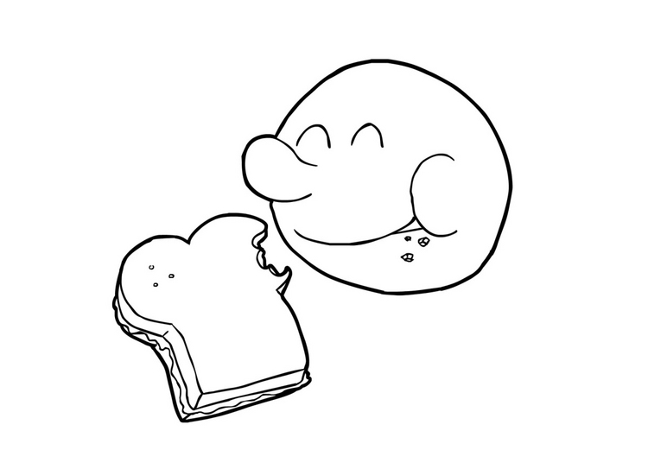

MANGER
______mange______

◻

_____________________________________________________________________________________________
© 2002 – AM pédagogie
Verbe

MANGER
______mangent____

◻

_____________________________________________________________________________________________
© 2002 – AM pédagogie
Verbe

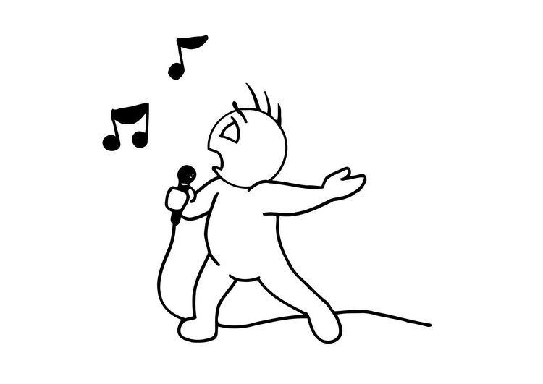

CHANTER
______chante______

◻

_____________________________________________________________________________________________
© 2002 – AM pédagogie
Verbe

CHANTER
______chantent____

◻

_____________________________________________________________________________________________
© 2002 – AM pédagogie
Verbe

COURIR
______court_____

◻

_____________________________________________________________________________________________
© 2002 – AM pédagogie
Verbe

COURIR
______courent_____

◻

_____________________________________________________________________________________________
© 2002 – AM pédagogie
Verbe

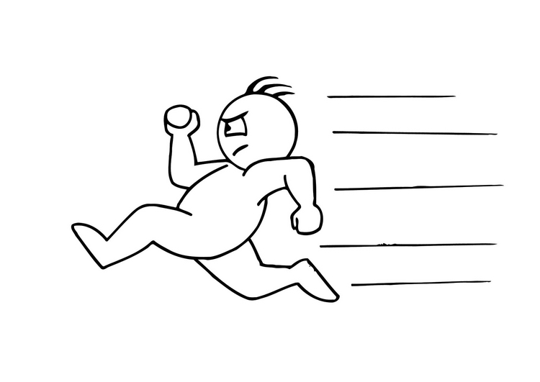

LIRE
______lirent_____

◻

_____________________________________________________________________________________________
© 2002 – AM pédagogie
Verbe

LIRE
______lit_____

◻

_____________________________________________________________________________________________
© 2002 – AM pédagogie
Verbe

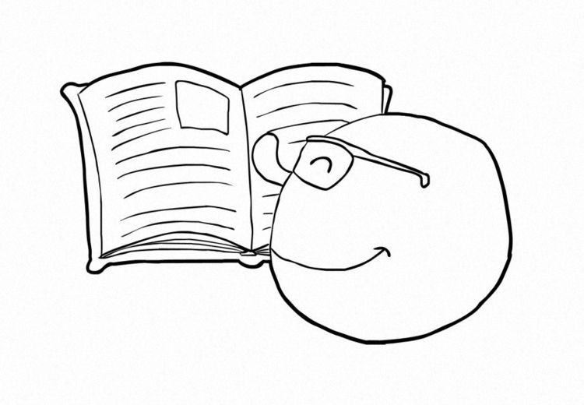

TOUSSER
______toussent_____

◻

_____________________________________________________________________________________________
© 2002 – AM pédagogie
Verbe

TOUSSER
______tousse_____

◻

_____________________________________________________________________________________________
© 2002 – AM pédagogie
Verbe

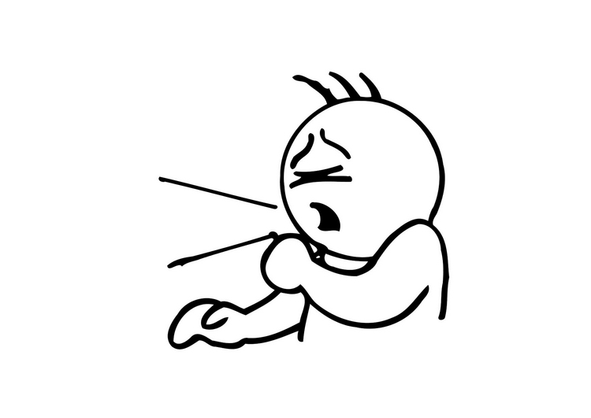

ELEVE
______Les élèves_____

◻

_____________________________________________________________________________________________
© 2002 – AM pédagogie
Sujet

ELEVE
______L’élève_____

◻

_____________________________________________________________________________________________
© 2002 – AM pédagogie
Sujet

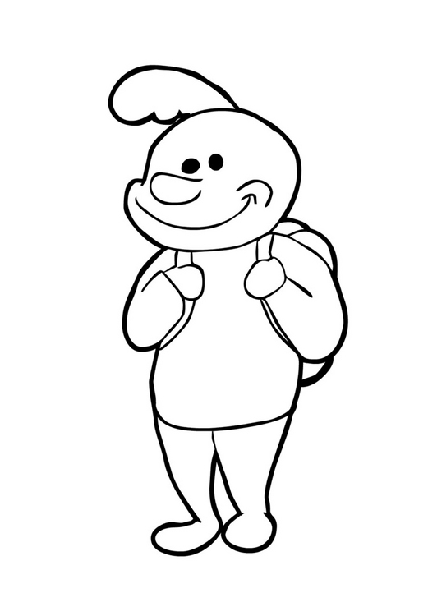

DAUPHIN
______Ces dauphins_____

◻

_____________________________________________________________________________________________
© 2002 – AM pédagogie
Sujet

DAUPHIN
______Ce dauphin_____

◻

_____________________________________________________________________________________________
© 2002 – AM pédagogie
Sujet

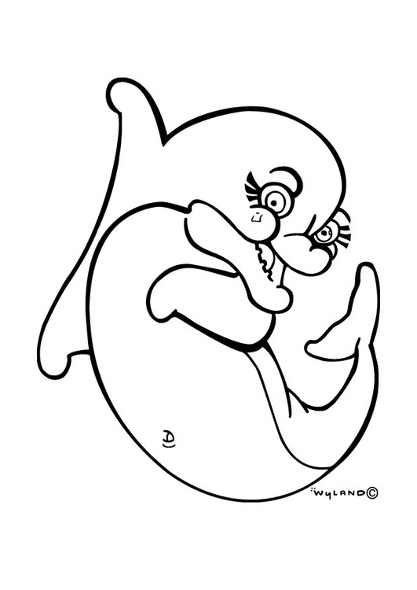

BEBE
______Ton bébé_____

◻

_____________________________________________________________________________________________
© 2002 – AM pédagogie
Sujet

BEBE
______Tes bébés_____

◻

_____________________________________________________________________________________________
© 2002 – AM pédagogie
Sujet

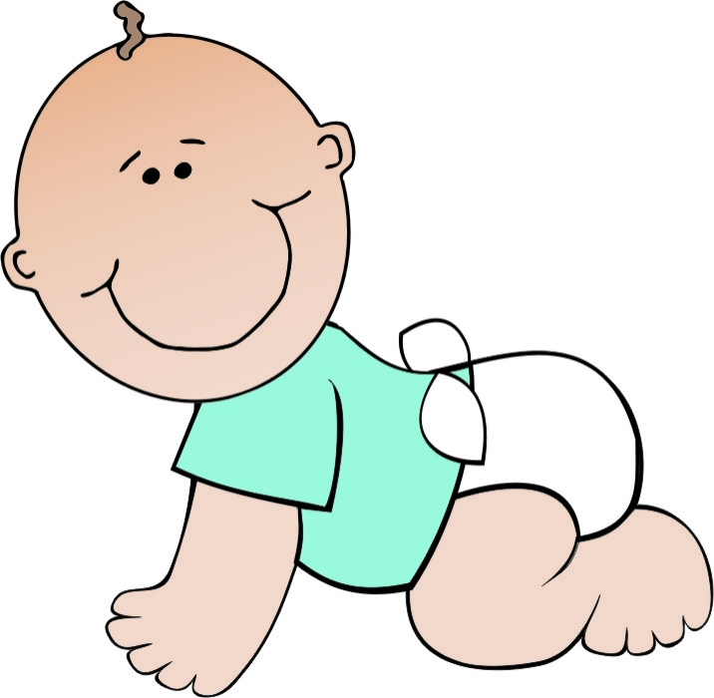

LAPIN
______Un lapin_____

◻

_____________________________________________________________________________________________
© 2002 – AM pédagogie
Sujet

LAPIN
______Des lapins_____

◻

_____________________________________________________________________________________________
© 2002 – AM pédagogie
Sujet

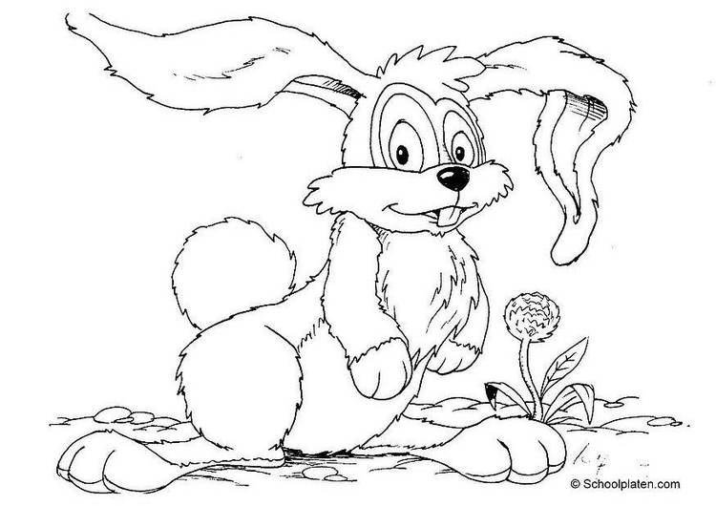

OISEAU
______L’oiseau_____

◻

_____________________________________________________________________________________________
© 2002 – AM pédagogie
Sujet

OISEAU
______Les oiseaux___

◻

_____________________________________________________________________________________________
© 2002 – AM pédagogie
Sujet

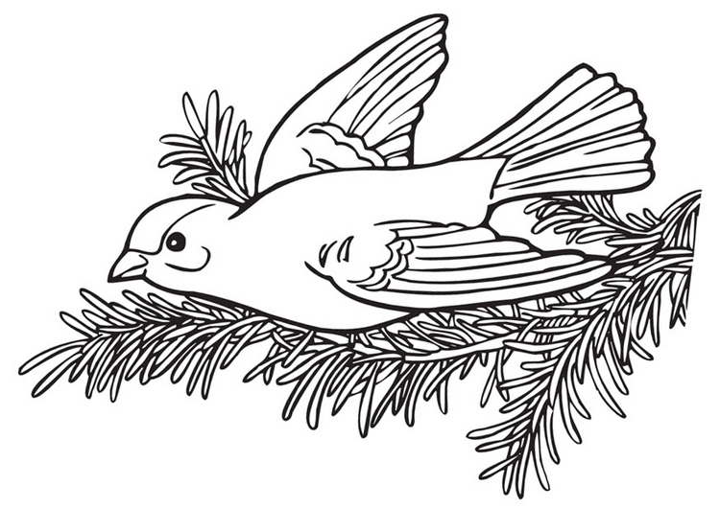

DOCTEUR
______Le docteur_____

◻

_____________________________________________________________________________________________
© 2002 – AM pédagogie
Sujet

DOCTEUR
_____Les docteurs____

◻

_____________________________________________________________________________________________
© 2002 – AM pédagogie
Sujet

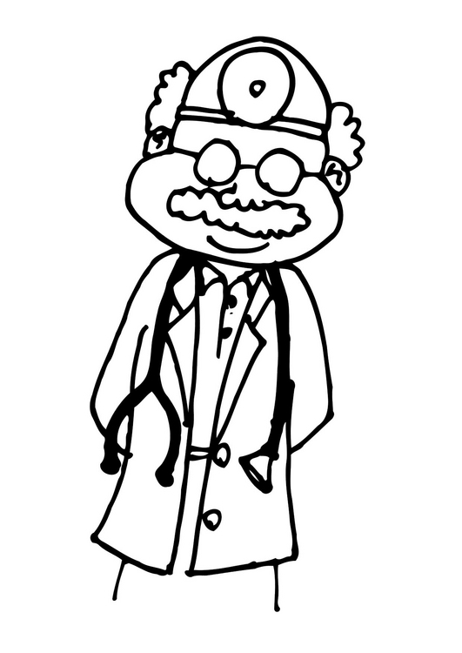

MAMAN
______Ma maman_____

◻

_____________________________________________________________________________________________
© 2002 – AM pédagogie
Sujet

MAMA N
____Nos mamans___

◻

_____________________________________________________________________________________________
© 2002 – AM pédagogie
Sujet

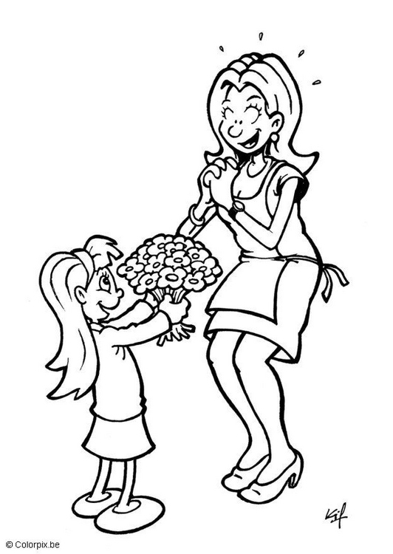

VOITURE
______Ta voiture_____

◻

_____________________________________________________________________________________________
© 2002 – AM pédagogie
Sujet

VOITURE
______Tes voitures_____

◻

_____________________________________________________________________________________________
© 2002 – AM pédagogie
Sujet

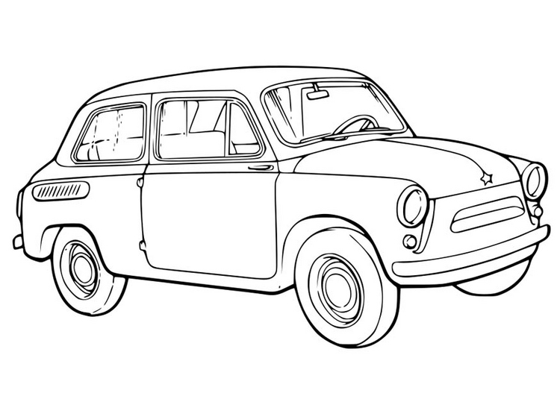

INSTITUTRICE
_____Son institutrice____

◻

_____________________________________________________________________________________________
© 2002 – AM pédagogie
Sujet
INSTITUTRICE
____Ses institutrices___

◻

_____________________________________________________________________________________________
© 2002 – AM pédagogie
Sujet

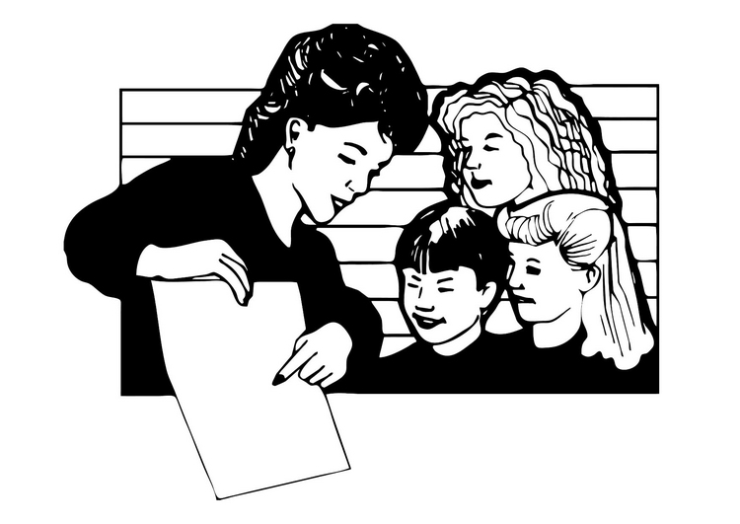

CYCLISTE
______ Ces cyclistes _____

◻

_____________________________________________________________________________________________
© 2002 – AM pédagogie
Sujet

CYCLISTE
______Ce cycliste_____

◻

_____________________________________________________________________________________________
© 2002 – AM pédagogie
Sujet

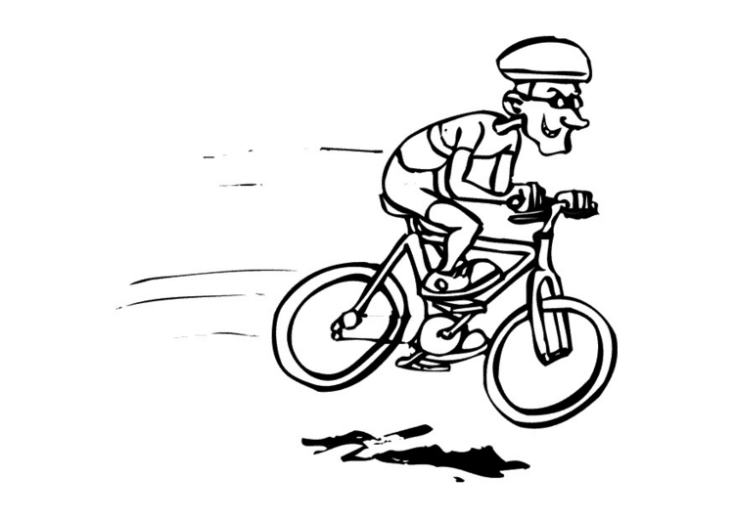

ROULER
______roulera_____

◻

_____________________________________________________________________________________________
© 2002 – AM pédagogie
Verbe

ROULER
______Rouleront_____

◻

_____________________________________________________________________________________________
© 2002 – AM pédagogie
Verbe
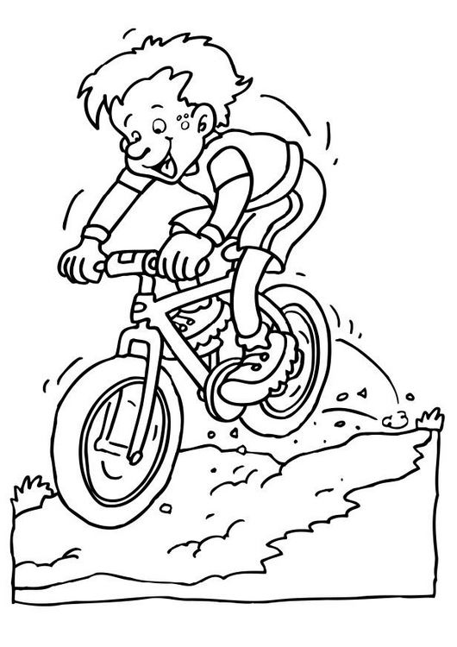
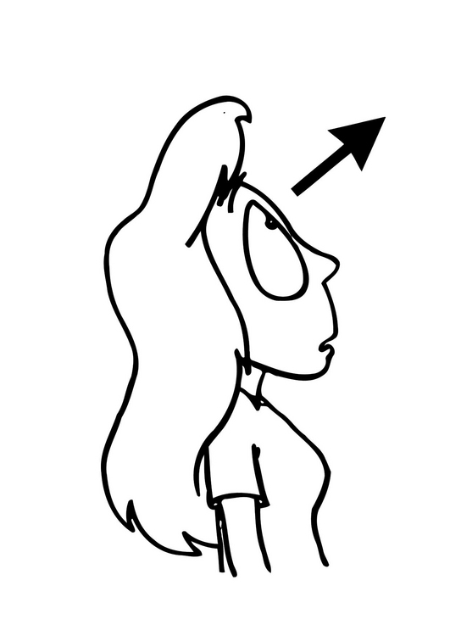
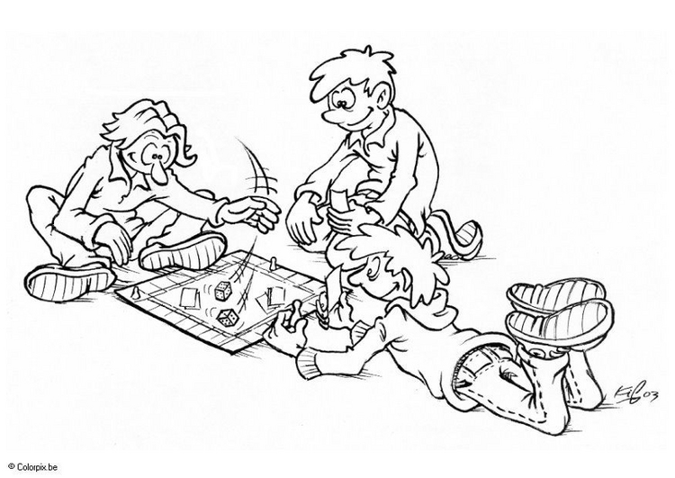

JOUER
______joue_____

◻

_____________________________________________________________________________________________
© 2002 – AM pédagogie
Verbe

JOUER
______jouent_____

◻

_____________________________________________________________________________________________
© 2002 – AM pédagogie
Verbe

REGARDER
______regardait_____

◻

_____________________________________________________________________________________________
© 2002 – AM pédagogie
Verbe

REGARDER
______regardaient_____

◻

_____________________________________________________________________________________________
© 2002 – AM pédagogie
Verbe

ECRIRE
______écrit_____

◻

_____________________________________________________________________________________________
© 2002 – AM pédagogie
Verbe

ECRIRE
______écrivent_____

◻

_____________________________________________________________________________________________
© 2002 – AM pédagogie
Verbe

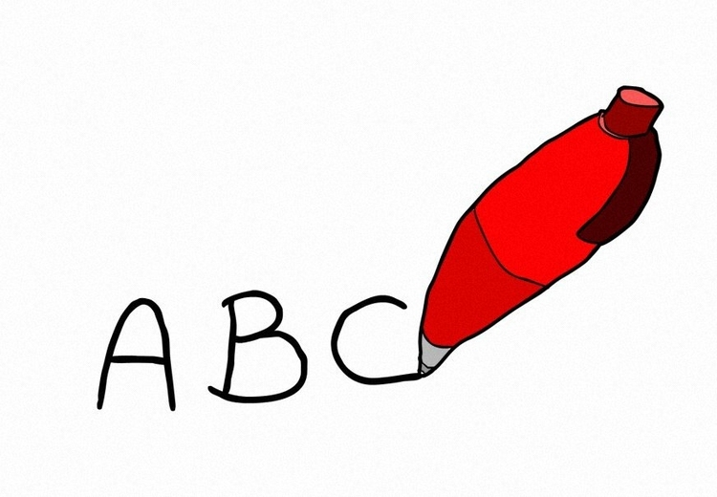

TELEPHONER
______téléphonera_____

◻

_____________________________________________________________________________________________
© 2002 – AM pédagogie
Verbe

TELEPHONER
______téléphoneront_____

◻

_____________________________________________________________________________________________
© 2002 – AM pédagogie
Verbe

