Test on Number 11 (part one)
1. Ring groups of 11 butterflies.


2. Ring groups of 11 eggs.

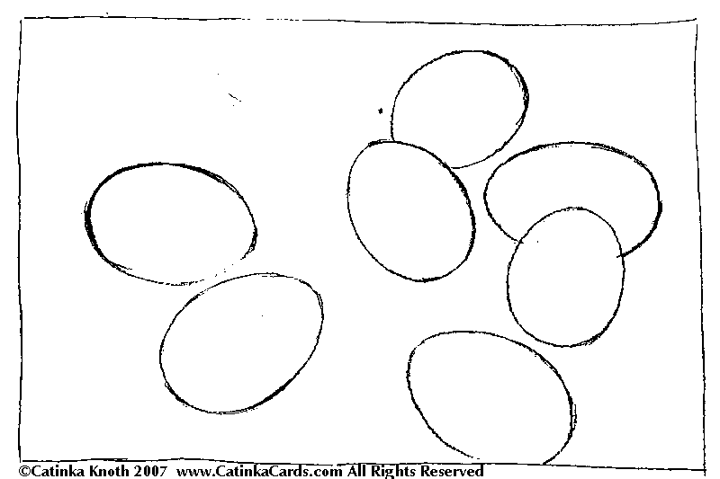

3. Ring the eleventh.





4. Write the number 11 on the lines of numbers.

Counting with 11! (Part 2)

3 + 8 = | 11 – 1=
7 + 2 = | 11 – 3 =
5 + 6 = | 11 – 5 =
4 + 6 = | 11 – 7 =
11 + 0 = | 11 – 9 =

5 + 6 = 5 + 5 + 1 = .... | 11 – 7 = 11 – 1 – …. = ….
11 – 2 = 11 – 1 – …. = ….

