Shapes
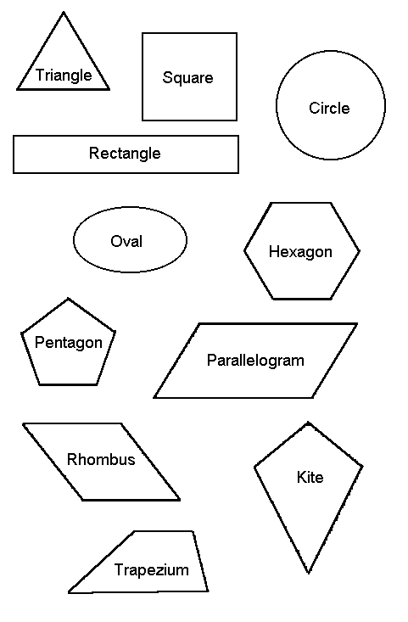
Name:………….
Colour the Shapes - Squares RED, Rectangles BLUE, Circles GREEN, Ovals ORANGE, Triangles YELLOW, Pentagons PINK and Hexagons PURPLE
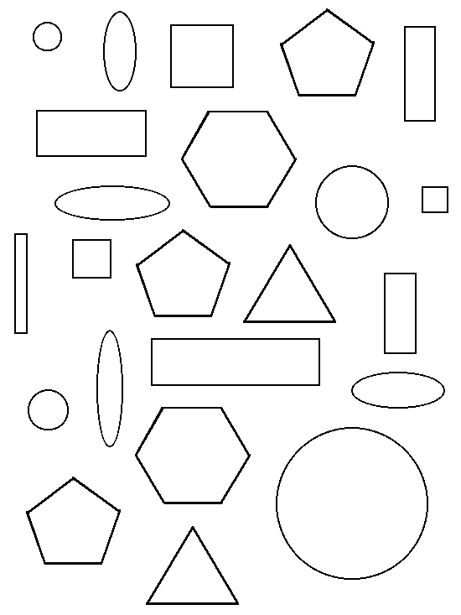
Match the Shapes - Draw a line from each shape to its name
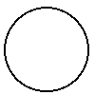 |  | Oval
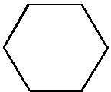 |  | Square
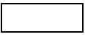 |  | Triangle
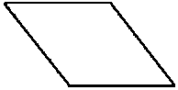 |  | Circle
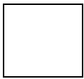 |  | Rhombus
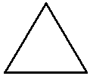 |  | Rectangle
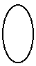 |  | Hexagon

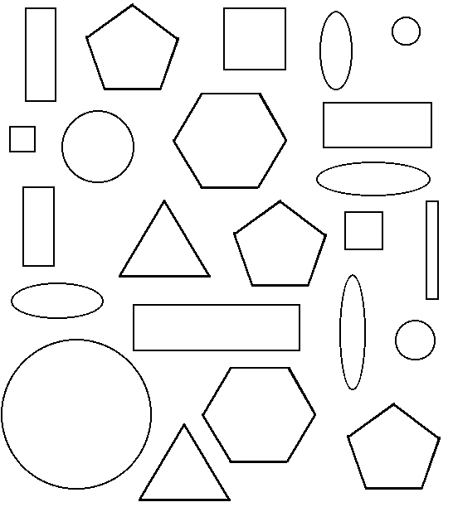
Shape | How many?
Squares
Rectangles
Circles
Ovals
Pentagons
Hexagons
Triangles
Shapes and their Properties
Shape | Number of Sides | Number of Corners
Square
Rectangle
Triangle
Circle
Oval
Rhombus/Lozenge

