Quelques animaux
____________________________ __________________

1 | 2 | 3 | 4 | 5 | 6 | 7 | 8 | 9 | 10 | 11 | 12 | 13 | 14 | 15 | 16 | 17 | 18
A | B | C | D | E | F | G | H | I | J | K | L | M | N | O | P | Q | R
19 | 20 | 21 | 22 | 23 | 24 | 25 | 26 |  | 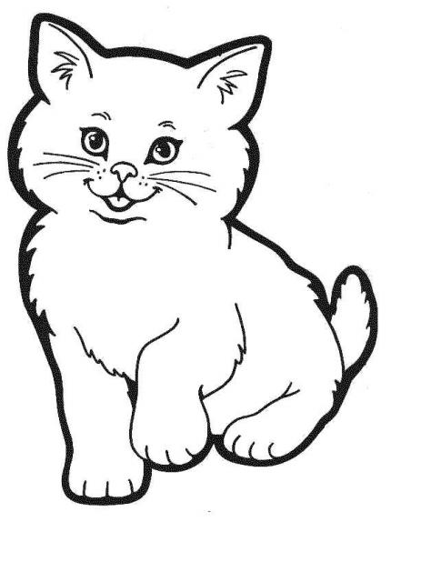 |  |  |  | 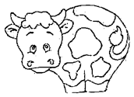
S | T | U | V | W | X | Y | Z
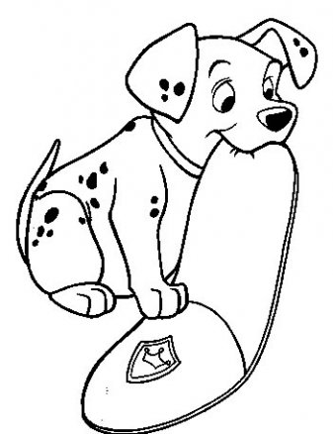

11 | 15 | 5

11 | 1 | 20

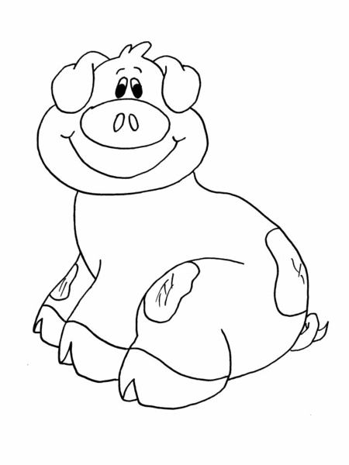

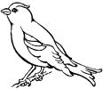
8 | 15 | 14 | 4

22 | 15 | 7 | 5 | 12

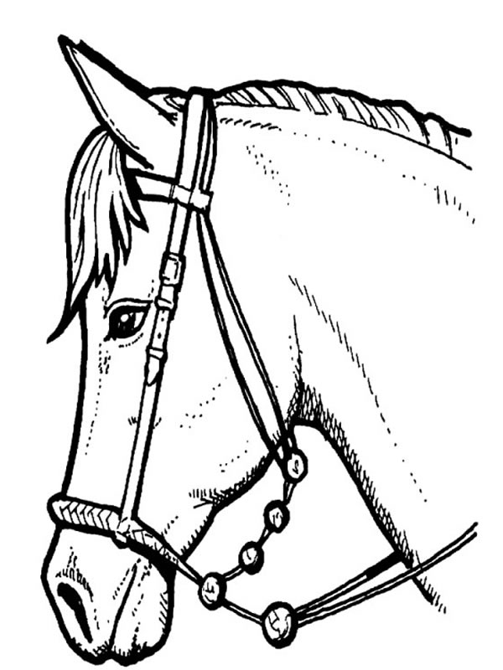
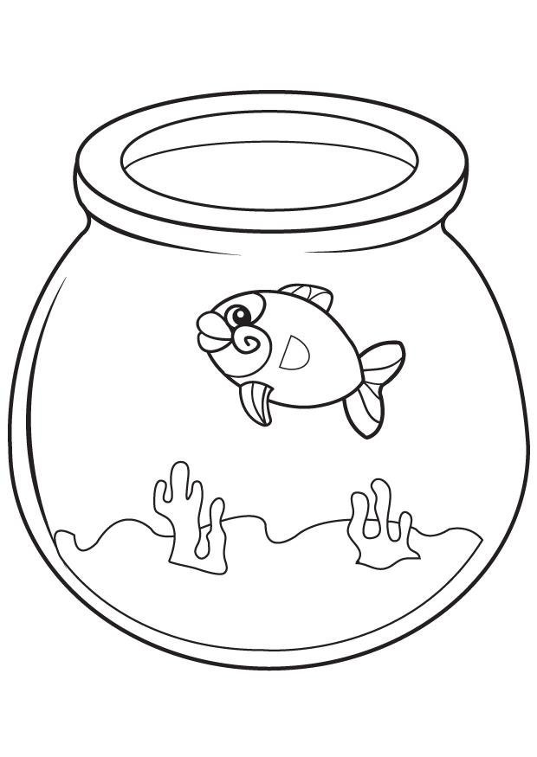
22 | 1 | 18 | 11 | 5 | 14

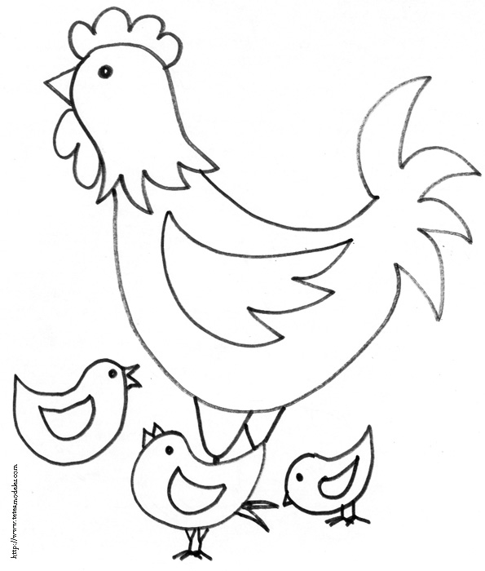

16 | 1 | 1 | 18 | 4

22 | 9 | 19

11 | 9 | 16

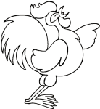
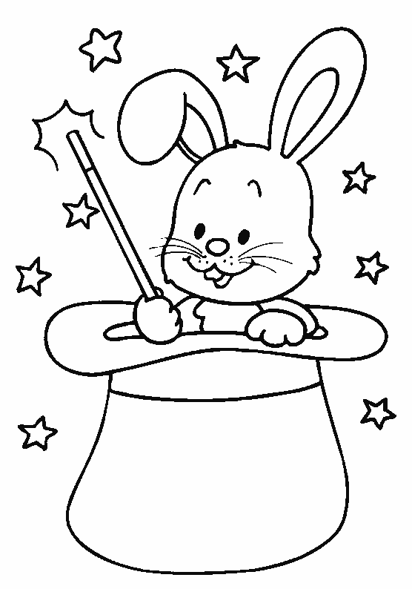


8 | 1 | 1 | 14

13 | 21 | 9 | 19

11 | 15 | 14 | 9 | 10 | 14

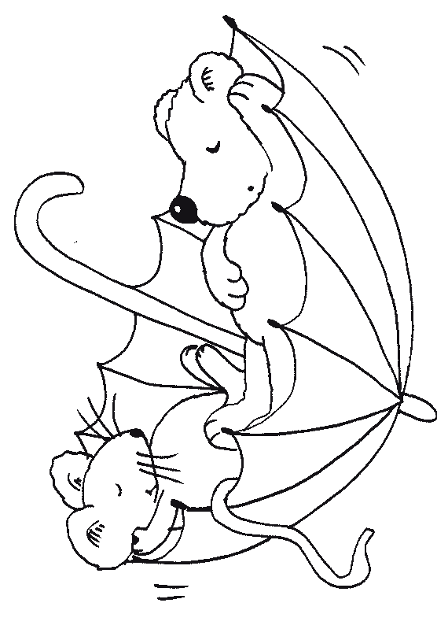

Relie (utilise ta latte).

²het ²konijn  |  | ❍ ²le ²coq
²de ²kat  |  | ❍ ²le ²cochon
²de ²haan  |  | ❍ ²le ²lapin
²het ²varken  |  | ❍ ²le ²cheval
²het ²paard  |  | ❍ ²le ²chat
²de ²kip  |  | ❍ ²l’²oiseau
²de ²vogel  |  | ❍ ²la ²souri$
²de ²vi$  |  | ❍ ²le ²chien
²de ²koe  |  | ❍ ²la ²poule
²de ²mui$  |  | ❍ ²le ²poisson
²de ²hond  |  | ❍ ²la ²vache

