Sciences

Lungs and breathing

- Look at the diagram and read the text.
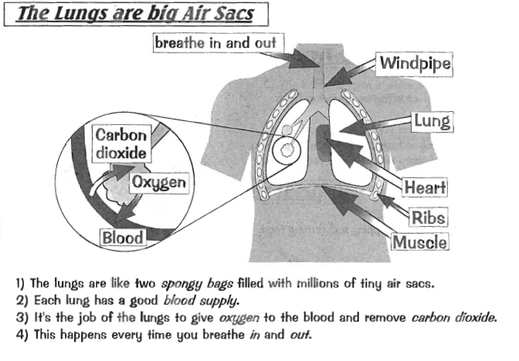
- Read the following text and fill in the gaps.

Each time you breathe in, air enters your body through your…………………and ……………………… .
You breathe in ………………………………times a day.
The air moves down your trachea or …………………………………….to your …………………………..
In the ……………………….the oxygen from the ……………………………is absorbed in the ………………………
The blood will transport the ……………………………………around your body.
All the little parts of your body (the ………………………) need oxygen to remove ………………………..from the food you eat.
When the oxygen has been used by the ………………….., carbon dioxide passes from your blood back to your …………………….
The …………………………………….dioxide leaves your body each time you breathe ………………..

- Link the words of the different organs with their definition

The lungs | a |  | 1 | This is where the air enters your body
The windpipe or trachea | b |  | 2 | Muscles below your lung
The diaphragm | c |  | 3 | This is where the air enters your body
The bronchi | d |  | 4 | Tiny air sacs
The mouth | e |  | 5 | Tunnel from your throat to your lungs
The nose | f |  | 6 | They look like sponges
The alveoli | g |  | 7 | Two tunnels bringing the air into your lungs

- Copy the words of the different organs below:

……………………………………………………………………………………………………………………………………………………………………………….
……………………………………………………………………………………………………………………………………………………………………………….
……………………………………………………………………………………………………………………………………………………………………………….

All these organs make up your …………………………………………..

5. Put these words on the right place on the following diagram.

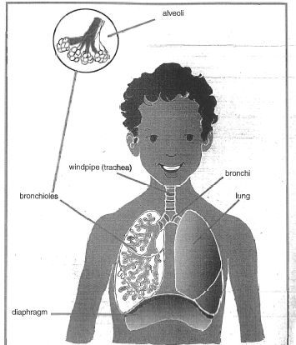

- Use colors to show the trip of air, oxygen and carbon dioxide when you breath.

Blue = oxygen
Red = carbon dioxide

7. Read this and talk about it:

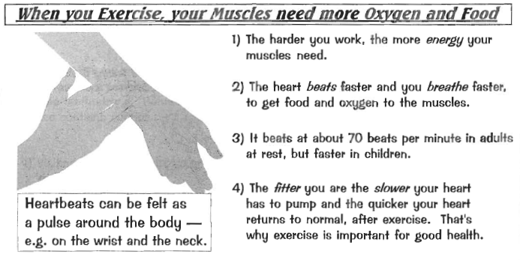

- Write in the correct word to complete these sentences. Choose a word from the box.
Sneezing yawning coughing pant

- When you are tired, you take in more oxygen into your body by……………………………….

- When dust irritates the inside of your nose, you blow it out by…………………………..

- When you have been running fast, you may have to …………………….to take in enough oxygen.

- When you have a cold, you remove mucus from your windpipe by…………………………………

- Can you make your own diagram of the Respiratory system?

My respiratory system

