Name: …………………………………………………… Date: ……………………………………………………. P2

History: Look at the pictures. (1)

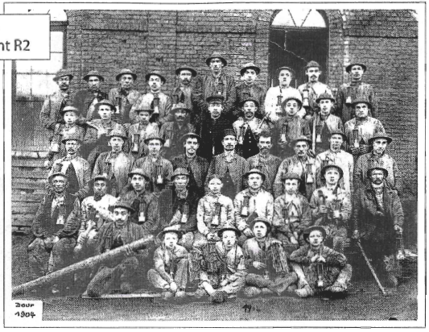
Look at this document and answer the following questions.

1. This document is an original document (choose the correct answer)
a restored document

2. This document is a photography
a painting
an engraving

3. This picture has been taken in Belgium / somewhere else. (underline your answer)
Explain your choice using a clue from the document.

……………………………………………………………………………………………………………………………………………..

4. Besides the miners, who else was a witness of this scene?

………………………………………………………………………………………………………………………………………

5. Trace a circle around the person who seems to be the leader of this team.

6. The miners’ work is a dangerous job. Find a clue proving this statement.

……………………………………………………………………………………………………………………………………………..

My vocabulary

