Science
Science: Mammals

1. Look at the picture
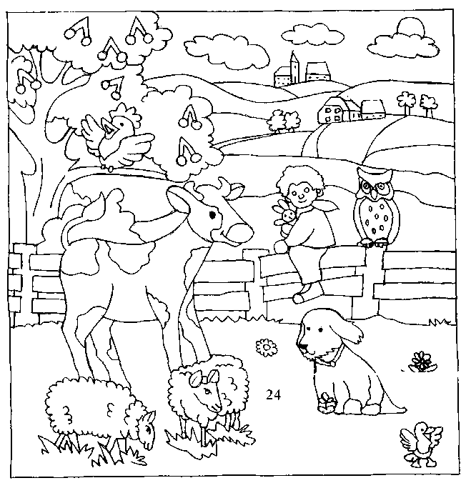
Write the names of the animals in the picture.
Oviparous animals | Viviparous animals

2. Read the sentences, cross out what’s wrong and write them correctly.

- The dog and the owl are plants.
- Dogs are birds and owls are mammals.

3. Read this text

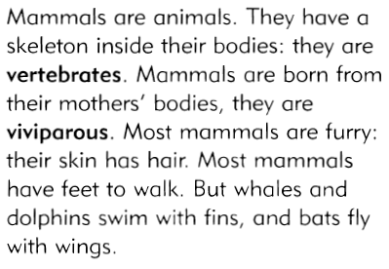

4. Colour these skeletons and complete the sentences

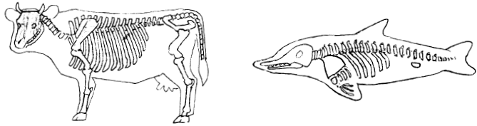

…………………………… and dolphins are mammals.
They are vertebrates which means that they have a …………..………………inside their body.

5. Match

dog * |  | * no hair
dolphin * |  | * wool
sheep * |  | * hair

6. Can you answer Pupi’s question?

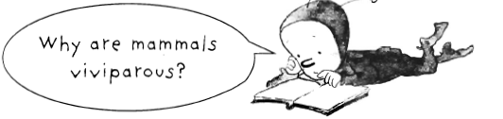

Mammals are viviparous because they are born from……………………………………………………………..

7. All these sentences are wrong. Write them correctly.

Whales
walk.
Bats
swim.

Zebras
Elephants
fly.
swim.
Monkeys
fly.

