1) Mets les lettres dans le bon ordre et retrouve le nom de l’animal.

ISHF :
IPG :
OHSER :
TAC :
OWC :
BIRABT:
PGONIE:

2) Entoure l’animal que tu entends.

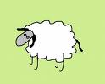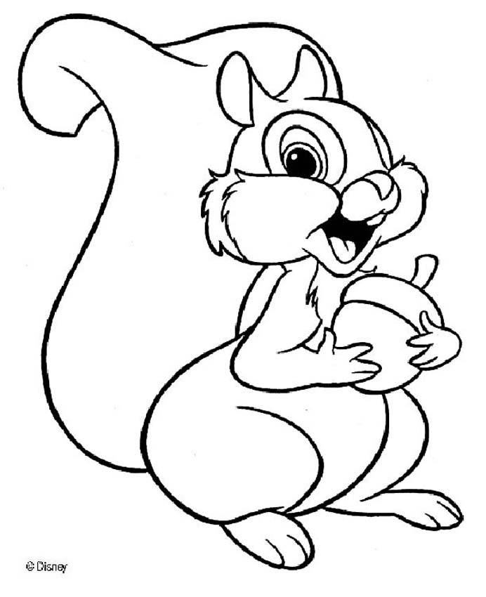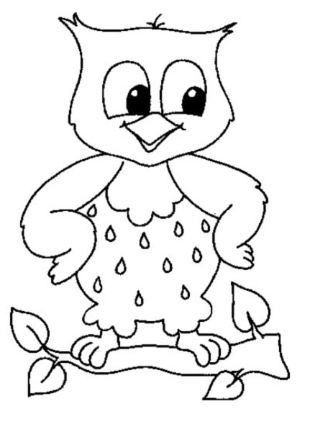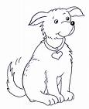

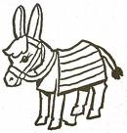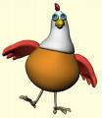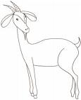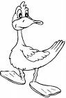

3) Recherche les mots dans le tableau

W | E | H | K | K | Q | P | R | A | B | B | I | T | U | B | S
D | U | C | K | A | Z | F | L | Y | Q | D | G | K | C | O | W
R | A | Z | E | T | B | R | N | M | I | H | K | S | K | T | A
I | H | F | I | S | H | O | W | L | C | H | I | C | K | E | N
B | O | A | S | C | B | G | J | K | M | D | Q | V | T | T | F
Q | R | L | M | I | R | X | V | N | D | O | N | K | E | Y | A
D | S | D | G | O | A | T | W | N | L | G | P | J | D | M | A
D | E | J | K | P | S | X | S | Q | U | I | R | R | E | L | C
M | O | U | S | E | Q | N | M | P | A | P | D | S | L | M | A
W | N | I | R | D | S | L | B | I | R | D | A | F | D | V | T
S | H | E | E | P | Q | M | L | G | D | S | K | L | U | M | P

