Introduce those celebrities
Pour chaque star, écris un petit texte en Anglais grâce à leur carte d’identité


Surname: Abril
First name: Victoria
Age : 42
City : Madrid
Country: Spain
Family: 1 sister
Language: Spanish and
French
Surname: Cruise

First name: Tom
Age :39
City :Los-Angeles
Country: America
Family: Only child
( no brother or sister)
Language: English
Surname: Belucci

First name: Monica
Age : 38
City : Rome
Country: Italy
Family: 1 sister and 2
brothers
Language: Italian, English
and French Surname: Elmaleh
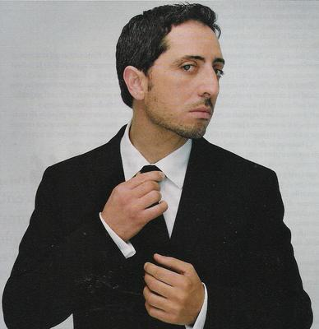
First name: Gad
Age : 37
City : Paris
Country: France
Family: 4 brothers
Language: French

