The weather : Exercise

- Write the letter of the picture next to the correct word.

a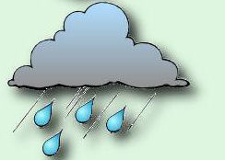 b c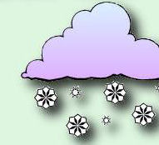 d 

e f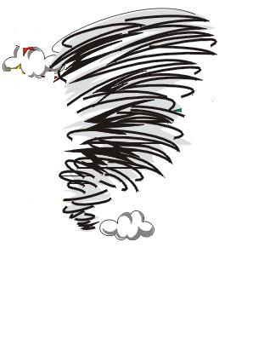 g  h 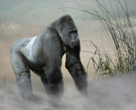

The sun ….. The hurricane …..
The fog ….. The mist …..
The cloud ….. The rain …..
The wind ….. The snow …..

- Bind the same words with the good sentence.

The sun 0 0 It’s misty

The fog 0 0 It’s snowing

The cloud 0 0 It’s foggy

The wind 0 0 The sun is shining

The mist 0 0 It’s raining

The rain 0 0 It’s cloudy

The snow 0 0 It’s windy

