De Werelddelen

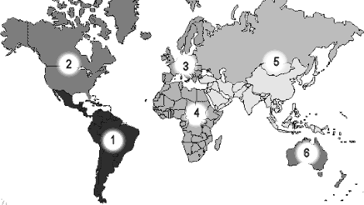

1 |  | 3 |  | 5
2 |  | 4 |  | 6

