Last name : Class :
First name : Date :

Reading Comprehension /10

Here is a letter from a mother to her son. She went to work early in the morning, and he’s on holiday, so she asks him to go shopping for her today. Write the names of the words in bold on the map. Don’t forget to draw the way on the map too.

First of all, you have to go to the bookshop to give some books back. Get off the underground at Edgar Quinet station. Go straight on towards the cinema. Turn right, and then right again. On your left, you can see the shopping centre. Go past this shopping centre and turn left. The bookshop is on your right, at the end of the street.

After that, I’ll ask you to go to the bakery because I need some bread. When you go out of the bookshop, go straight on. Go through the crossroads. On your left, there is a small shop, called “Diana’s house”, I really like it, it’s awesome, go inside and have a look if you have some time ! Take the first street on your right. Mike’s house is on the left, at the end of the road, and just in front of it, you can see the bakery. Can you buy me some bread ?

When you go out of the bakery, I’d like you to buy some ham in the butcher shop. When you go out of the bakery, turn left.. At the end of the road, take the first on the right ! (Be careful, this crossroads is quite dangerous!).Then, take the first on the left. It is a very small road, it’s called “Narrow Road”) and the butcher shop is at the corner, on your left, next to a garage.

After that, go out of the butcher shop, and turn left into Narrow Road. Take the first on the right, you are on the avenue again. Turn right, go past the cinema. At the next junction, go straight on. The dentist is on your left. The market is on the other side of the road. Don’t be late for your appointment with the dentist at 11.30 !
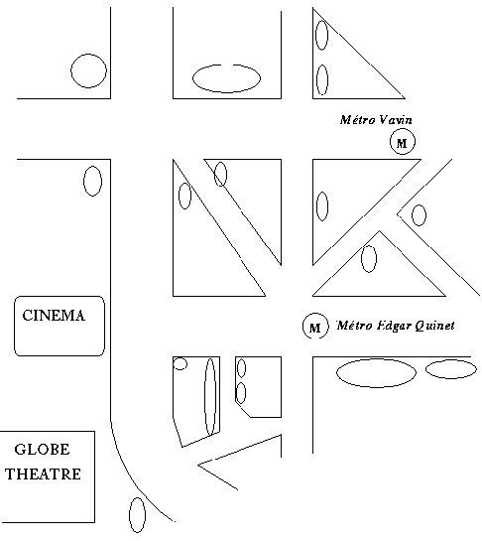
Be careful !

… Mum …

