Name: date:

Write the name of what you can see on the photo. Indicate if it’s countable (C)or uncountable (u) (Write C or U).

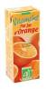
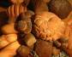
____________________
_____________________
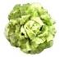
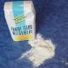

_________________ _____________________

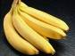

_________________ ________________
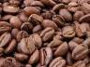
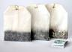
________________
____________________

Choose two countable and two uncountable words from exercise 3. Write questions using some and any. Use four different verbs.

Word chosen | Question
Tomatoes | How many tomatoes do you eat?

