Put the verbs into the past simple

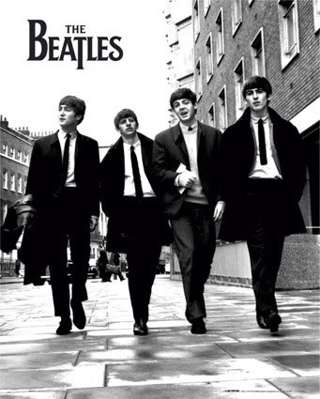
The Beatles
The Beatles ____________ (to be) a rock and pop group formed in Liverpool, England in 1960 who _______(to become) one of the most commercially successful and critically acclaimed* bands in the history of music. The band ___________________ (to consist of) John Lennon (rhythm guitar, vocals), Paul McCartney (bass guitar, vocals, piano), George Harrison (lead guitar, vocals) and Ringo Starr (drums, vocals).
The single "Please Please Me"____________(to be) a success in the UK charts* in late 1962. The group _____________ (to attract) a lot of interest, termed* "Beatlemania", during tours of the UK and Europe throughout the next year. They were against the Vietnam War and it was a problem for the American government. As a result, the government didn’t want John Lennon to stay in the United States and deported* him. In 1967 the group _______________ (to meet) Maharishi Mahesh Yogi, who _____________(to introduce) them to meditation. The same year, their manager _______________(to die) from an overdose. The group ___________ (to spend) time in India, treating the Maharishi as their guru for a short time, but ______________(to become) disillusioned with him. Increasingly dominated by conflict, the group disintegrated* in 1970. All four members __________________( to begin) successful solo careers.
The Beatles ______________________(to sell) one billion* records internationally. According to the Recording Industry Association of America, they have sold more albums in the United States than any other band. Lennon was killed in 1980, in New York City. Marc David Chapman ____________________ (to murder) him: he ______________(to shoot) Lennon four times. The tragedy ___________(to take) place* when his wife, Yoko Ono was present. George Harrison ____________ (to die) of lung* cancer in 2001.
Richard Starkey (Ringo Sarr) and Paul McCartney are still alive.

A little help:

To acclaim: to applause, to praise
Charts: hit parade
Termed: called
Deported: forced him to go away
Disintegrated: separated
A billion: a thousand million.
To take place: to happen
Lungs: without them, you could not breathe

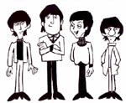
1. Read about the Beatles and correct the false affirmations.
- The Beatles formed in Manchester.
The Beatles didn’t form in Manchester. They formed in Liverpool.
- The band consisted of five musicians.
______________________________________________________________________________________________________________________________________________________________
- Paul Mc Cartney was married to Yoko Ono.
______________________________________________________________________________________________________________________________________________________________
- The Beatles were pro-war in Vietnam.
______________________________________________________________________________________________________________________________________________________________
- Maharishi Mahesh Yogi was George Harrison’s father.
______________________________________________________________________________________________________________________________________________________________
- John Lennon is still alive.
______________________________________________________________________________________________________________________________________________________________
- Paul McCartney died from lung cancer.
______________________________________________________________________________________________________________________________________________________________
- The group disintegrated in 1960.
______________________________________________________________________________________________________________________________________________________________
2. Listen to the teacher and write the dates.
Death of John Lennon | Ringo Starr’s birthday | John Lennon and Yoko Ono met on this day: | first Beatles single release (Love me do) | Paul McCartney’s birthday
//Go lesson 42: TEACHER
The Beatles
The Beatles were a rock and pop group formed in Liverpool, England in 1960 who became one of the most commercially successful and critically acclaimed bands in the history of music. The band consisted of John Lennon (rhythm guitar, vocals), Paul McCartney (bass guitar, vocals, piano), George Harrison (lead guitar, vocals) and Ringo Starr (drums, vocals).
The single "Please Please Me" was a success in the UK charts in late 1962. The group attracted a lot of interest, termed "Beatlemania", during tours of the UK and Europe throughout the next year. They were against the Vietnam war and it was a problem for the American government. As a result, the government didn’t want John Lennon to stay in the United States and deported him. In 1967 the group met Maharishi Mahesh Yogi, who introduced them to Meditation. The same year, their manager died from an overdose. The group spent time in India, treating the Maharishi as their guru for a short time, but became disillusioned with him. Increasingly dominated by conflict, the group disintegrated in 1970. All four members began successful solo careers.
The Beatles sold one billion records internationally. According to the Recording Industry Association of America, they have sold more albums in the United States than any other band. Lennon was killed in 1980, in New York City. Marc David Chapman murdered him: he shot Lennon four times. The tragedy took place when his wife, Yoko Ono was present. George Harrison died of lung cancer in 2001.
Richard Starkey (Ringo Sarr) and Paul McCartney are still alive.

A little help:

To acclaim: to applause, to praise
Charts: hit parade
Termed: called
Deported: forced him to go away
Disintegrated: separated
A billion: a thousand million.
To take place: to happen
Lungs: without them, you could not breathe

.

Exercises:
Read about the Beatles and correct the false affirmations.
- The Beatles formed in Manchester.
The Beatles didn’t form in Manchester. They formed in Liverpool.
- The band consisted of five musicians.
The band didn’t consist of five musicians. It consisted of four musicians.
- Paul Mc Cartney was married to Yoko Ono.
Paul McCartney wasn’t married to Yoko Ono. John Lennon was married to Yoko Ono.
4) The Beatles were pro-war in Vietnam.
The Beatles weren’t pro-war in Vietnam. They were against the war in Vietnam.
- Maharishi Mahesh Yogi was George Harrison’s father.
Maharishi Mahesh Yogi wasn’t George Harrison’s father. Maharishi Mahesh Yogi was the Beatles’ guru.
- John Lennon is still alive
John Lennon isn’t still alive. Ringo Starr and Paul Mc Cartney are still alive..
- Paul McCartney died from lung cancer.
Paul McCartney didn’t die from lung cancer. It was George Harrison who died from lung cancer.
- The group disintegrated in 1960.
The group didn’t disintegrate in 1960. It disintegrated in 1970.

Listen to the teacher and write the dates:
Death of John Lennon | Ringo Starr’s birthday: | John Lennon and Yoko Ono met on this day: | First Beatles’ single release (Love me do) | Paul McCartney’s birthday
8 December 1980 | 7 July 1940 | 9 November 1966 | 5 October 1962 | 18 June 1942

All you need is love
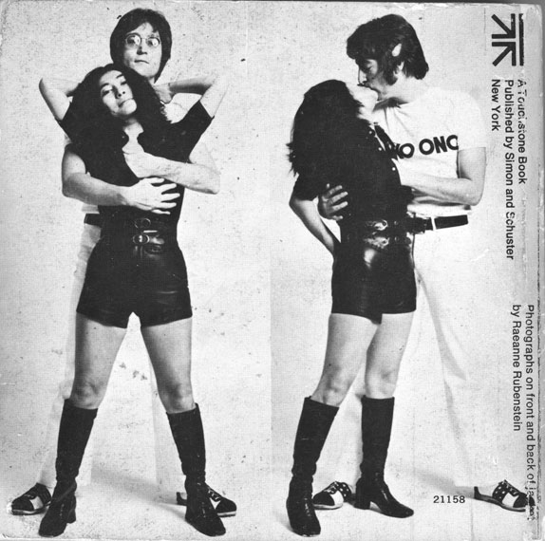

Love, love, love.
Love, love, love, love, love, love.
Love, love, love.
Love, love, love, love, love, love.
Love, love, love: It's easy! Ooh!
There's nothing you can do that can't be done.
Nothing you can sing that can't be sung.
Nothing you can say but you can learn how to play the game
It's easy.
There's nothing you can make that can't be made.
No one you can save that can't be saved.
Nothing you can do but you can learn how to be you in time
It's easy.

All you need is love
All you need is love,
All you need is love.
Love is all you need.
All you need is love
All you need is love,
All you need is love.
Love is all you need.
There's nothing you can know that isn't/can’t be known.
Nothing you can see that isn't shown.
Nowhere you can be that isn't where you're meant to be.
It's easy.
All you need is love
All you need is love,
All you need is love, love
Love is all you need.

All you need is love

Love, love, love.
Love, love, love, love, love, love.
Love, love, love.
Love, love, love, love, love, love.
Love, love, love: _________! Ooh!
There's nothing you can ____ that can't be ____.
Nothing you can _____ that can't be _____.
Nothing you can ______ but you can ______ how to play the game
It's easy.
There's nothing you can ______ that can't be _____.
No one you can _____ that can't be _____.
Nothing you can ____ but you can _____ how to be you in time
It's easy.

All you need is love
All you need is love,
All you need is love.
Love is all you need.
All you need is love
All you need is love,
All you need is love.
Love is all you need.
There's nothing you can _____ that isn't /can’t be _____.
Nothing you can _____ that isn't _____.
Nowhere you can _____ that isn't where you're _____to be.
It's easy.
All you need is love
All you need is love,
All you need is love, love
Love is all you need.

