Can/can’t : exercices

- Which of these tings can you do? Write sentences about you with can/can’t:

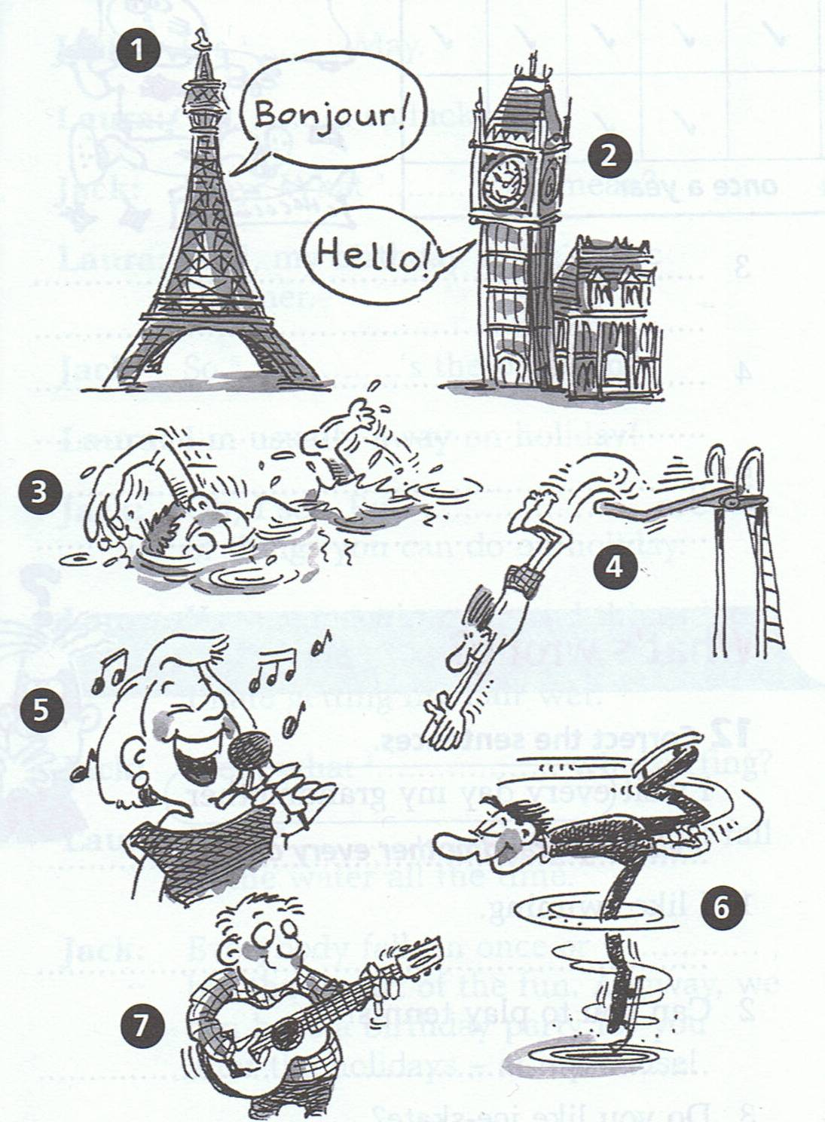

- Example : I can speak French. / I can’t speak French.
- …………………………………………………………………………………………………………………………………………
- …………………………………………………………………………………………………………………………………………
- …………………………………………………………………………………………………………………………………………
- …………………………………………………………………………………………………………………………………………
- …………………………………………………………………………………………………………………………………………
- …………………………………………………………………………………………………………………………………………
- Write negative sentences using the verbs from the list:
