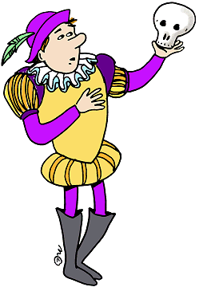

To be (être)

Forme affirmative | Forme raccourcie | Forme Négative | Forme interrogative
I am | I'm | I am not / I'm not | Am I?
You are | You're | You are not / You aren't | Are you?
He is | He's | He is not / He isn't | Is he?
She is | She's | She is not / She isn't | Is he?
It is | It's | It is not / It isn't | Is it?
We are | We're | We are not / We aren't | Are we?
You are | You're | You are not / You aren't | Are you?
They are | They're | They are not / They aren't | Are they?

Exemples (entoure le verbe être et traduis la phrase)

Where are you? …..........................................
What's your name? ….......................................
I'm in the garden. …....................................................
My name's Jake. ….....................................................
It's my house. …..........................................................
She isn't in the kitchen. ….........................................

Quand on répond à une question par oui ou par non, ne pas oublier la “short answer”
=> après yes, on utilise la forme affirmative ENTIERE (jamais raccourcie)
=> après no, on utilise la forme négative
Ex: Is Anisha in her bedroom? No, she isn't / is not.
Is it your house? Yes, ….................
Are you Jake? Yes, …......................
Are they Spanish? No, ….................

