REMINDER : HOW I calculate the time between two hours

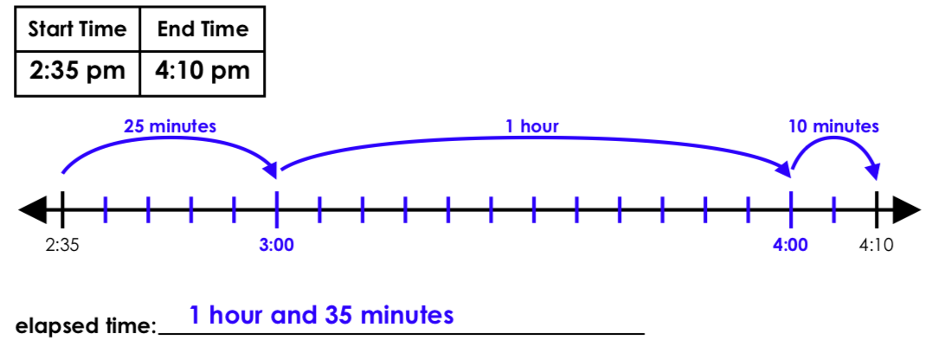

- I begin with my start time -> 2:35 PM
- I go to the next whole our -> 25 minutes to 3 o'clock
- If I go to an other whole hour -> 1 hour to 4 o'clock
- I go to my end time = 4:10 PM -> 10 minutes
→ The total elapsed time is 1 hour and 35 minutes

You begin with some word problems

I would like to see the decomposition

- I woke up at 7:15 and left for school at 8:22. How long did it take me to get ready?
………………………………………………………………………………………………………………………
………………………………………………………………………………………………………………………
………………………………………………………………………………………………………………………

- I began to read my book at 19:47 and finished the book at 20:03. How long was I reading for?
……………………………………………………………………………………………………………….
…………………………………………………………………………………………………………………
……………………………………………………………………………………………………………………
- I started my homework at 17:36 and completed it by 18:02. How long did it take me?
………………………………………………………………………………………………………………………
………………………………………………………………………………………………………………………
………………………………………………………………………………………………………………………

- I began watching a TV programme at 9:30 and it finished 34 minutes later. What time did it end?
………………………………………………………………………………………………………………………
………………………………………………………………………………………………………………………
………………………………………………………………………………………………………………………

- I began cooking my fairy cakes at 15:32 and it took me 45 minutes to cook and clear up. What time did I finish?
………………………………………………………………………………………………………………………
………………………………………………………………………………………………………………………
………………………………………………………………………………………………………………………

- I went to my 48 minute swimming lesson at 10:28. What time did it end?
………………………………………………………………………………………………………………………
………………………………………………………………………………………………………………………
………………………………………………………………………………………………………………………
- I began practising to play my recorder at 14:30. I practised for 59 minutes. What time did I finish?
………………………………………………………………………………………………………………………
………………………………………………………………………………………………………………………
………………………………………………………………………………………………………………………

- The 75 minute football match began at 13:22. What time did it end?
………………………………………………………………………………………………………………………
………………………………………………………………………………………………………………………
………………………………………………………………………………………………………………………

- The 27 minute assembly began at 10:10. Playtime lasted for 20 minutes. What time did the next lesson begin?
………………………………………………………………………………………………………………………
………………………………………………………………………………………………………………………
………………………………………………………………………………………………………………………

10. The children began their 55 minute Maths lesson at 09:10. Straight after that they had 25 minute music lesson. What time did both lessons end?
………………………………………………………………………………………………………………………
………………………………………………………………………………………………………………………

Write the equivalent times:

Analogue | 24 Hour
3:50 pm
2:33 pm
 | 17:38
 | 03:45
 | 00:15
8:50 am
9:25 pm
11:45 pm
 | 00:00

Complete the chart below.

