Les systèmes du corps humain : évaluation

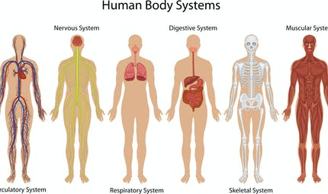

1. ***Pour chaque dessin, complète les différentes colonnes du tableau.***

|  |  |  |  |
| --- | --- | --- | --- |
| N° | Nom du système | A quoi il sert | Organe principal |
| 1 | __________________  __________________ | __________________________  __________________________  __________________________ | _______________ |
| 2 | __________________  __________________ | __________________________  __________________________  __________________________ | _______________ |
| 3 | __________________  __________________ | __________________________  __________________________  __________________________ | _______________ |
| 4 | __________________  __________________ | __________________________  __________________________  __________________________ | _______________ |
| 5 | __________________  __________________ | __________________________  __________________________  __________________________ | _______________ |
| 6 | __________________  __________________ | __________________________  __________________________  __________________________ | _______________ |

1. ***Pour chaque système, trouve une maladie, un problème, un accident … qui pourrait l’affecter.***
2. ___________________________________________________________________________________________________________________________________________________________________________________________________
3. ___________________________________________________________________________________________________________________________________________________________________________________________________
4. ___________________________________________________________________________________________________________________________________________________________________________________________________
5. ___________________________________________________________________________________________________________________________________________________________________________________________________
6. ___________________________________________________________________________________________________________________________________________________________________________________________________
7. ___________________________________________________________________________________________________________________________________________________________________________________________________